**Computing Research Project**

**Digital Transformation Strategies (DX)**

**Inventory Management System**



|  |  |
| --- | --- |
| **Name:** | **Wildan Luqmanul Hakim** |
| **Code:** | **STTB** |

**Lithan EduClaas  
2023**

**Contents**

ABSTRACT 2

RESEARCH PART (PART I) 2

1. Introduction 2

1.1 Research Background 2

1.2 Research Purpose 3

2. Literature Review 3

3. Research Plan 4

3.1 Research 4

3.2 Research Philosophy (Saunders’s Onion theory) 4

3.3 Gantt Chart and Work Breakdown Structures (WBS) for Research Proposal 5

4. Research Methodologies 6

4.1 Primary Research 6

4.1.1 Primary Research Methodologies 6

4.1.2 Survey 7

4.1.3 Interview 7

4.1.4 Observations 7

4.1.5 Focus Group 7

4.1.6 Merits/Demerits/Pitfalls for each method 7

4.2 Secondary Research 8

4.2.1 Sources of data 8

4.2.2 Secondary Research Methodologies 9

4.2.3 Merits/Demerits/Pitfalls for each method 9

4.3 Secondary Research (Desktop Research/ online research: Document analysis) 11

5. Research Approaches 11

5.1 Qualitative Research 11

5.1.1 Methodologies in Qualitative Research 11

5.1.2 Merits/Demerits of Qualitative Research 12

5.2 Quantitative Research 13

5.2.1 Methodologies in Quantitative Research 14

5.2.2 Merits/Demerits of Quantitative Research 14

6. Research Design 15

6.1 Saunders Research Onion Theory 15

6.2 Compare among research methods and research approaches **Comparison of data** Approaches 16

7. Research Conduct and Analysis 18

7.1 Conduct Primary Research 18

Project Part (Part II) 23

8. Project Proposal 23

a) Project Objective 23

b) Scope 23

c) Constraints 23

d) Assumptions 24

e) Project Environment 24

f) Project design 24

9. Communication with Stakeholders 43

10. Project Implementation 44

a) Back-end source code 44

b) Front-end source code 44

c) White box testing 50

d) Black box testing 55

11. Conclusion 60

12. Bibliography 61

# ABSTRACT

This research project focuses on developing an inventory management system for Jumpstart, a retail chain with 750 stores nationwide, to overcome the challenges posed by the post-COVID-19 business environment. The system aims to streamline the inventory management process and provide accurate and timely data to facilitate decision-making. The research involves using technologies such as VS Code, Google Chrome, Postman API, MongoDB Atlas, and programming languages like HTML, CSS, JavaScript, and TypeScript. The website's core features include real-time inventory tracking, automated order management, and customizable reports. The project also includes a testing plan, risk assessment, budget, milestones, and a detailed roadmap. The implementation of the system is expected to improve the accuracy and efficiency of the inventory management process, reduce manual labor, and provide better customer service.

# RESEARCH PART (PART I)

## Introduction

### Research Background

Inventory management is a crucial aspect of retail operations as it directly impacts the customer experience and the overall profitability of the business. With the emergence of new technologies and changing customer behaviors, inventory management has become more complex and challenging for retailers like Jumpstart. Moreover, the COVID-19 pandemic has disrupted the traditional retail business model, pushing retailers to adopt new strategies to stay competitive and relevant.

In response to these challenges, Jumpstart has decided to reshape its business model and lean towards customer commerce. This requires a robust and efficient inventory management system that can handle the demands of a rapidly changing business environment. To this end, Jumpstart has approached Aceadora Tech to provide a solution that can help them optimize their inventory management processes, improve the accuracy of data, reduce manual data entry and management, and enhance the speed of customer data retrieval.

This research project aims to develop and implement a new inventory management system for Jumpstart that can meet the evolving needs of the retail industry. The project will involve extensive research on best practices in inventory management, as well as the latest technologies and frameworks that can be used to build an efficient and reliable system. The ultimate goal is to provide Jumpstart with a scalable, user-friendly, and cost-effective solution that can help them streamline their operations, improve their customer experience, and stay ahead of the competition.

### Research Purpose

The purpose of this research is to explore and analyze the current inventory management practices of Jumpstart, a retail chain with 750 stores nationwide, and identify potential areas for improvement. The research aims to provide recommendations and solutions to overcome the challenges faced by Jumpstart due to the new norm of remote working in the post-Covid 19 era and to reshape their business model towards customer commerce. The research will also evaluate the effectiveness of implementing a new inventory management system to improve the accuracy, efficiency, and speed of the customer data management process and reduce the time spent on manual data entry and management.

## Literature Review

Inventory management is an essential process for any business to run efficiently, regardless of its size or industry. Effective inventory management can help reduce costs, increase productivity, and improve customer satisfaction. With the rise of e-commerce and the increasing demand for online shopping, the importance of inventory management has become more critical than ever.

Various inventory management techniques have been developed and implemented by businesses over the years. One of the most popular techniques is the just-in-time (JIT) inventory system. JIT is a demand-driven inventory management approach that aims to minimize inventory levels by producing and delivering products just in time when they are needed. This approach can help reduce inventory holding costs, but it requires a high level of coordination and efficiency in the supply chain.

Another popular inventory management technique is the ABC analysis. This technique involves classifying inventory items into categories based on their relative importance, with category A items being the most important and category C items being the least important. This approach helps businesses prioritize their inventory management efforts and allocate resources accordingly.

With the advancement of technology, businesses have also been able to implement automated inventory management systems that use data analytics, machine learning, and artificial intelligence to optimize inventory levels and improve supply chain efficiency.

However, despite the availability of these techniques and systems, many businesses still struggle with inventory management due to issues such as inaccurate demand forecasting, inefficient warehouse management, and poor communication and coordination within the supply chain.

Therefore, the research on inventory management for Jumpstart aims to identify the challenges faced by the retail chain in managing their inventory and propose effective solutions to improve their inventory management processes. The research will review existing literature on inventory management techniques, analyze Jumpstart's current inventory management practices, and provide recommendations for implementing effective inventory management strategies.

## Research Plan



### Research

Research is a systematic and scientific investigation or inquiry into a specific topic or problem, using a variety of methods and techniques to gather and analyze data, in order to generate new knowledge or validate existing knowledge. The aim of research is to increase our understanding of a particular subject or phenomenon, and to contribute to the development of theories, concepts, or practical applications. Research can be conducted in various fields, including science, social science, humanities, engineering, and medicine, among others.

### Research Philosophy (Saunders’s Onion theory)

Saunders’s Onion Theory is a multi-layered approach to research philosophy that helps to clarify the researcher's ontological and epistemological position. In the context of the research on inventory management for Jumpstart, the researcher's ontological position would be that there is an objective reality of inventory management, and the epistemological position would be that this reality can be studied and understood through a combination of empirical observation and theoretical analysis.

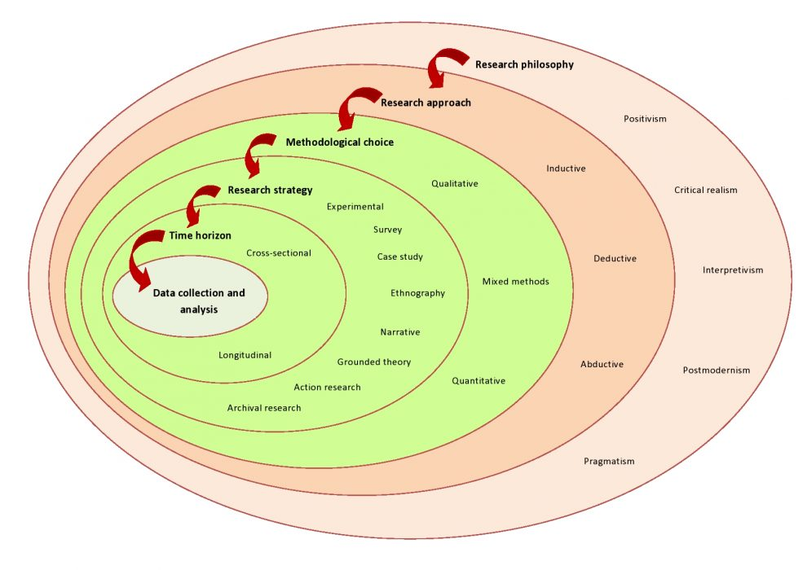

The first layer of the onion theory is the research paradigm, which in this case would be the positivist paradigm. This paradigm assumes that there is an objective reality that can be observed and measured, and that the research should strive to be value-neutral and free from bias.

The second layer is the research design, which in this case would be a combination of quantitative and qualitative methods. The researcher would use quantitative data to measure inventory levels, turnover rates, and other relevant metrics, while also using qualitative data to gather insights into the experiences and perceptions of Jumpstart's employees and customers.

The third layer is the research strategy, which in this case would be a case study approach. The researcher would focus on Jumpstart as a single case and gather detailed information about the inventory management practices and challenges specific to this company.

The fourth layer is the time horizon, which in this case would be cross-sectional. The research would be conducted at a specific point in time, with the aim of capturing a snapshot of the current inventory management situation at Jumpstart.

The final layer is the techniques of data collection and analysis, which would include methods such as surveys, interviews, and data analysis software. The researcher would use a combination of these techniques to gather and analyze both quantitative and qualitative data, with the goal of developing a comprehensive understanding of Jumpstart's inventory management practices and identifying areas for improvement.

### Gantt Chart and Work Breakdown Structures (WBS) for Research Proposal

A Gantt chart is a popular tool used in project management to visually represent the project schedule and track progress. It is a bar chart that shows the timeline of a project, with each task represented by a horizontal bar that stretches across the project timeline. The start and end dates of each task are shown on the chart, as well as the dependencies between tasks.

In the context, Gantt chart could be used to plan and schedule the different tasks involved in the research project, such as data collection, analysis, and reporting. It could also help to identify any dependencies between tasks and potential delays, allowing for adjustments to be made to the schedule accordingly.

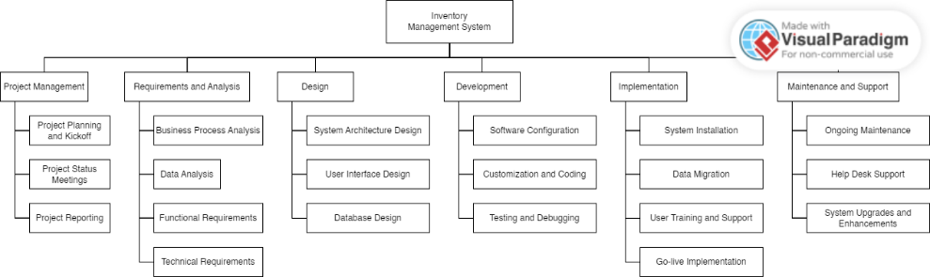

WBS stands for Work Breakdown Structure. It is a project management tool used to divide a project into smaller, more manageable tasks. The WBS is hierarchical in nature, meaning that the project is broken down into smaller, more manageable components or work packages. Each work package includes a description of the task, its deliverables, and the resources required to complete it.

In the context of "Research on Inventory Management for Jumpstart," the WBS would be used to break down the research project into smaller, more manageable components, such as literature review, data collection, data analysis, and report writing. Each of these components would then be further divided into smaller tasks and assigned to team members to complete within a given time frame. The use of a WBS helps to ensure that all aspects of the project are covered, and that each team member understands their specific role and responsibilities.

## Research Methodologies



### Primary Research

Primary research entails gathering new data directly from the source rather than using data that has already been collected and published by others. Rather than relying on secondary sources, this type of research is conducted by the researcher or their team to obtain information that is specific to their research question.

### Primary Research Methodologies

Primary research methodologies are techniques used to gather new data or information directly from the source. These methods involve collecting original data through surveys, interviews, observations, experiments, or focus groups. Primary research is conducted to answer specific research questions, investigate a particular topic, or test a hypothesis.

### Survey

Surveys are questionnaires that are used to collect data from a large number of respondents. Surveys can be conducted in person, over the phone, through mail, or online. They can be structured or unstructured and can be used to gather both quantitative and qualitative data.

### Interview

Interviews involve asking questions to a selected group of individuals to gain insight into their experiences, opinions, attitudes, and behaviors. Interviews can be conducted in person, over the phone, or online.

### Observations

Observations involve collecting data by watching and recording behavior or events. Observations can be conducted in a natural setting or a controlled environment and can be structured or unstructured.

### Focus Group

Focus groups involve bringing together a group of individuals to discuss a particular topic or issue. Focus groups are typically led by a moderator and are designed to gather qualitative data about attitudes, opinions, and behaviors.

### Merits/Demerits/Pitfalls for each method

|  |  |  |  |
| --- | --- | --- | --- |
| **No** | **Methodology** | **Merits** | **Demerits** |
| 1 | Survey | * Has the ability to quickly gather a lot of data from a variety of participants. * Can be administered in person or remotely. * Responses can be structured to ensure uniformity. * Enables statistical analysis to find patterns and trends. | * May be biased by how they responded or report things incorrectly. * May not fully express how complex a participant's thoughts or experiences are. * Low response rates could cause problems with representativeness. |
| 2 | Interview | * Enables the thorough investigation of a participant's ideas, experiences, and viewpoints. * Can adjust to the comfort level and communication style of the participant. * Can immediately clarify and question responses. * May present surprising insights or results. | * Possibly time- and resource-consuming. * May be biased by social desirability or response. * Is susceptible to the interviewer's own prejudices or beliefs. * Can lead to misunderstandings or poor communication. |
| 3 | Observation | * Permits the gathering of information about natural phenomena or behavior. * Without relying on self-reporting, can produce objective data. * Can offer perceptions into the setting and context of a specific behavior or activity. | * May be biased or misinterpreted by the observer. * Possibly does not fully represent the breadth of experiences or drivers behind a given behavior. * It might be difficult to observe certain behaviors or environments from an ethical or practical standpoint. |
| 4 | Focus group | * Explores the dynamics of groups and common experiences. * Can produce a wealth of qualitative information on attitudes, convictions, and experiences. * Can help participants feel a sense of belonging and understanding. | * Can be influenced by participants who are loud or dominant. * The full range of experiences or perspectives within the group might not be fully represented. * Is liable to conformity bias or groupthink. * Because of the complexity of group interactions, analysis can be difficult. |

### Secondary Research

Secondary research involves the collection and analysis of existing data, information, and research findings that have been previously conducted by other researchers. This data can be obtained from a variety of sources such as books, journals, articles, online databases, government reports, and other published materials

### Sources of data

Secondary research sources of data refer to the already existing data that is collected, processed, and analyzed by someone else for a different purpose. These data sources can be classified into two broad categories:

1. Internal Sources:

These are the sources of data that come from within the organization, such as financial reports, sales reports, customer data, inventory data, and other such data that the organization collects and processes as part of its day-to-day operations.

1. External Sources:

These are the sources of data that come from outside the organization, such as published reports, industry studies, government publications, census reports, trade journals, newspapers, and other such sources that provide information relevant to the organization's research needs.

### Secondary Research Methodologies

Secondary research methodologies involve collecting data from previously published sources, rather than gathering original data through methods like surveys or experiments. Some common secondary research methodologies include:

1. Literature Reviews:

A comprehensive analysis of previously published literature related to a specific research question or topic.

1. Meta-Analysis:

A statistical method that combines the findings from multiple studies to provide an overall estimate of the effect size.

1. Systematic Reviews:

A method of reviewing literature that follows a strict set of guidelines to ensure objectivity and reproducibility.

1. Content Analysis:

A method of analyzing written, audio or visual content to identify patterns and themes.

### Merits/Demerits/Pitfalls for each method

|  |  |  |  |
| --- | --- | --- | --- |
| **No** | **Methodology** | **Merits** | **Demerits** |
| 1 | Literature Review | * Gives a thorough understanding of the research that has already been done on a particular subject or problem. * Can be helpful for spotting holes or contradictions in the literature. * Can lead to the creation of fresh research questions and theories. * Can be completed reasonably quickly and cheaply. | * May be harmed by publication bias, which occurs when only studies with noteworthy findings are published. * Can be constrained by the caliber and applicability of the literature at hand. * May rely on out-of-date or incorrect data. * Possibly does not fully represent the range of experiences or perspectives on the subject. |
| 2 | Meta-analysis | * Gives a statistical summary of the research that has already been done on a certain subject or problem. * Can be used to find relationships and patterns across various studies. * Can offer a more accurate estimation of the impact of a variable or intervention than a single study. * Can be used to test hypotheses that the initial studies did not specifically test. | * May be constrained by the caliber and number of studies that are available for analysis. * May be influenced in the choice of studies by publication bias or other types of bias. * Can be affected by variations in study populations or study design. * The heterogeneity of the studies included in the analysis might be a limitation. |
| 3 | Systematic Reivew | * Gives a thorough and organized method for reviewing and combining existing research. * Can be used to find gaps and contradictions in the literature. * Can offer a more thorough understanding of the body of evidence supporting a specific intervention or phenomenon. * Can be helpful for creating evidence-based recommendations or guidelines. | * Conducting research can be time- and resource-intensive. * May be constrained by the caliber and number of studies that are available for analysis. * May be influenced in the choice of studies by publication bias or other types of bias. * The heterogeneity of the studies included in the analysis might be a limitation. |
| 4 | Content Analysis | * Offers a methodical, impartial way to evaluate huge amounts of data. * Can be applied to find themes and patterns in written or visual content. * Can be used to investigate the attitudes, convictions, and values that are expressed in the data. * Can be used to come up with fresh theories or inquiries. | * May be constrained by the standard and applicability of the data at hand. * Is susceptible to the researcher's personal interpretations of the data. * May be constrained by the challenge of coding or categorizing complex data. * Possibly does not fully represent the range of experiences or perspectives on the subject. |

### Secondary Research (Desktop Research/ online research: Document analysis)

## Research Approaches



### Qualitative Research

Qualitative research is a type of research method that involves exploring and understanding the perceptions, experiences, and opinions of individuals through non-numerical data analysis. It aims to provide an in-depth understanding of human behavior, attitudes, and motivations. This method often involves open-ended questions, interviews, focus groups, observations, and content analysis.

### Methodologies in Qualitative Research

1. Interview

A technique for gathering information through private discussions between the researcher and participants. Interviews can be conducted in person, over the phone, or online, and they can be structured, semi-structured, or unstructured.

1. Focus Grup

A technique for gathering information that involves a researcher and a small group of participants having group discussions. Focus groups are frequently used to examine the attitudes and experiences of participants in relation to a specific topic.

1. Observation

A technique for gathering information that involves watching and documenting participants' actions and interactions in their natural surroundings. Both structured and unstructured observations are possible, and the researcher may participate or not.

1. Content Analysis

A process of deciphering patterns, themes, and meanings in textual or visual data, such as transcripts, documents, or images.

1. Case Study

A technique for gathering information through extensive, ongoing investigations of a specific case or phenomenon. Multiple data collection techniques, including interviews, observation, and document analysis, can be used in case studies.

### Merits/Demerits of Qualitative Research

|  |  |  |  |
| --- | --- | --- | --- |
| **No** | **Methodology** | **Merits** | **Demerits** |
| 1 | Interview | * Permit a thorough investigation of the experiences, attitudes, and beliefs of participants. * Adaptable to various contexts and circumstances * Give participants access to rich, specific data that can help shed light on their motivations and thought processes. | * Can be time- and resource-consuming. * May be biased or distorted due to the interviewer's individual beliefs or experiences. * Possibly not representative of the general populace |
| 2 | Focus Group | * Permit group discussion of participants' attitudes and experiences. * Can shed light on social interactions and group dynamics * Can be a reasonably effective way to collect information from numerous participants at once. | * In a group setting, participants might not feel at ease expressing their opinions. * The dynamics of the group may skew participants' opinions or responses. * The information might not accurately reflect the general population. |
| 3 | Observation | * Direct, first-hand information about participants' interactions and behavior * Can capture subtle, complex details that other techniques might miss * Can offer a deep comprehension of the social and cultural environment in which participants operate. | * Observer bias or distortion could apply. * Participants' inner experiences or motivations might not be captured. * Possibly time- or resource-consuming |
| 4 | Content Analysis | * Capable of efficiently analyzing large amounts of data * Can provide a systematic, repeatable method for analyzing textual or visual data. * Can reveal patterns and themes in data that may not be immediately apparent. | * The complexity of participants' experiences or attitudes might not be fully captured. * Researcher bias or interpretation could play a role. * Not necessarily appropriate for all kinds of data or research questions |
| 5 | Case Study | * Allows for a thorough investigation of a specific case or phenomenon * Can deliver rich, detailed data that accurately reflects the complexity of participants' perceptions and experiences * Can be an effective technique for investigating novel or underexplored research areas. | * It might not be applicable to other situations or populations * Possibly time- and resource-consuming * Researcher bias or interpretation could play a role. |

### Quantitative Research

Quantitative research is a research methodology that aims to measure, analyze and quantify data using statistical and mathematical methods. It involves collecting numerical data and using statistical analysis techniques to identify patterns, trends, and relationships between variables.

### Methodologies in Quantitative Research

1. Survey

Surveys involve asking a set of questions to a large number of people in order to collect quantitative data. Surveys can be conducted in person, over the phone, through email or online forms.

1. Experiment

Experiments involve manipulating one or more variables to observe their effect on a particular outcome. Experiments can be conducted in a laboratory or in a natural setting.

1. Meta-analysis

Meta-analysis involves synthesizing data from multiple studies to draw broader conclusions about a particular topic. Meta-analysis can be used to establish the strength of an effect, identify sources of variability, and explore potential moderators of an effect.

### Merits/Demerits of Quantitative Research

|  |  |  |  |
| --- | --- | --- | --- |
| No | Methodology | Merits | Demerits |
| 1 | Survey | * Because they can be completed quickly and are relatively inexpensive in comparison to other research methods, surveys are a common research method. * Surveys are helpful for studying populations because they can reach a lot of participants. * Depending on the types of questions used in the survey, both quantitative and qualitative data can be collected. | * Response bias, in which respondents provide incomplete or inaccurate answers, can affect surveys. * Low response rates are a problem for surveys, especially those that are conducted online. * In comparison to other techniques like interviews or focus groups, surveys might not be able to capture the breadth and depth of participant experiences. |
| 2 | Experiment | * Experiments are effective research techniques for testing hypotheses because they can establish cause-and-effect relationships between variables. * Experiments can be carefully controlled, increasing internal validity and minimizing the impact of unrelated variables. * Depending on the kind of measurements used, experiments can gather both quantitative and qualitative data. * To determine whether research findings are generalizable, experiments can be repeated. | * Conducting experiments can be expensive and time-consuming, especially if it requires finding participants or using specialized tools. * Demand characteristics, where participants may alter their behavior as a result of the experimental context, can hurt experiments. * Experiments might not always accurately represent actual circumstances, which could reduce their external validity. |
| 3 | Meta-analysis | * A meta-analysis can bring together information from various studies to give a more thorough understanding of a research question. * Since meta-analysis can use a larger sample size than individual studies, it can offer greater statistical power. * Patterns and trends that may not be obvious in individual studies can be found through meta-analysis. * Meta-analysis can improve effect size precision and lessen the impact of coincidental findings. | * The quality of the studies included in the meta-analysis can have limitations because low-quality studies can skew the results in general. * Meta-analysis can take a lot of time and requires knowledge of research design and statistics. * Not all research questions may benefit from meta-analysis, especially if there is significant study heterogeneity. |

## Research Design



### Saunders Research Onion Theory

Saunders Research Onion Theory is a conceptual framework that illustrates the various layers of a research process. The theory is named after Professor Mark Saunders and it provides a structured approach to conducting research. The onion has different layers, with each layer representing a different aspect of the research process. The layers are as follows:

1. Philosophical position:

This layer defines the overall approach to the research, including the researcher's worldview, beliefs, and values.

1. Research approach:

This layer describes the broad methodology or approach that the researcher has chosen for their study, such as qualitative, quantitative, or mixed-methods.

1. Research strategy:

This layer involves the specific techniques or tools that the researcher will use to collect data, such as surveys, interviews, or case studies.

1. Time horizon:

This layer refers to the timeframe for the research, including whether it is cross-sectional or longitudinal.

1. Data collection:

This layer focuses on the actual process of collecting data, including how it will be collected, who will collect it, and where it will be collected.

1. Data analysis:

This layer involves the process of analyzing the data that has been collected, including the techniques that will be used and the software that will be employed.

1. Findings:

This layer includes the results of the analysis, the conclusions drawn from the research, and any recommendations for future research.

### Compare among research methods and research approaches **Comparison of data Approaches**

|  |  |
| --- | --- |
| **Quantitative Research** | **Qualitative Research** |
| In order to test hypotheses, spot patterns, and draw statistical inferences, quantitative research focuses on gathering and analyzing numerical data. | Through in-depth investigation and analysis of non-numerical data, qualitative research is a type of research methodology that aims to comprehend and explore social phenomena and human behavior. |

Conclusion:

Among other disciplines, quantitative research is frequently used in psychology, economics, sociology, and political science to address questions that can be resolved using numerical data. The findings of quantitative research can be applied to a larger population because the data are typically based on a representative sample of the population under study.

For questions that can be answered with numerical data, quantitative research is frequently used in disciplines like psychology, economics, sociology, and political science, among others. It is possible to generalize the results of quantitative research because the data is typically based on a representative sample of the population under study.

**Comparison among primary methods:**

|  |  |  |
| --- | --- | --- |
| **Survey** | **Interview** | **Observation** |
| A survey is a questionnaire that is given to lots of people in order to learn about their attitudes, beliefs, behaviors, or demographics. Surveys are frequently used to gather information on a variety of subjects and are especially helpful for getting quantitative information. While surveys are frequently less expensive and time-consuming than other methods, they might not be as comprehensive or insightful. | To gather information on a particular subject, interviews entail one-on-one discussions between the researcher and the participant. Interviews can be structured, semi-structured, or unstructured and offer detailed information on the perspectives and experiences of participants. However, conducting effective interviews can take a lot of time and may require extensive training. | In an uncontrolled or natural environment, observations entail the methodical observation and recording of behavior. When studying complex or delicate subjects, observations can offer detailed information on behavior and interactions. However, conducting effective observations can take a lot of time and may require advanced training. |

Conclusion:

In surveys, a set of questions are posed to a large number of participants in order to gather quantitative data. You can conduct surveys in-person, on the phone, via email, or online using forms. A survey is a questionnaire that is given to lots of people in order to learn about their attitudes, beliefs, behaviors, or demographics. Surveys are frequently used to gather information on a variety of subjects and are especially helpful for getting quantitative information.

**Comparison of secondary methods**

|  |  |  |
| --- | --- | --- |
| **Literature Review** | **Meta-Analysis** | **Systematic Review** |
| A literature review is a summary of the body of research on a specific topic. It entails analyzing and condensing written works, such as books, articles, and other scholarly sources. A literature review's objectives are to find gaps in the body of knowledge and give an overview of what is known about a particular research topic at this time. | In order to find patterns or relationships, meta-analysis is a statistical analysis that combines the findings of various studies on a given subject. In most cases, meta-analysis entails the quantitative analysis of data from numerous studies and makes use of statistical methods to combine the findings of these studies into a single summary measure. | A systematic review is a thorough and meticulous analysis of the body of knowledge on a specific research question. It entails a comprehensive review of all relevant literature, a critical evaluation of the caliber of the studies included, and a methodical synthesis of the results of these studies. Meta-analyses are frequently used in systematic reviews, but they can also be qualitative in nature. |

Conclusion:

In order to find patterns or relationships, meta-analysis is a statistical analysis that combines the findings of various studies on a given subject. In most cases, meta-analysis entails the quantitative analysis of data from numerous studies and makes use of statistical methods to combine the findings of these studies into a single summary measure.

## Research Conduct and Analysis



### Conduct Primary Research

1. **Consider Costs, Access And Ethical Issues**

|  |  |
| --- | --- |
| **Survey Considerations** | **Description** |
| Cost | Google Form is open-source tool to create the survey form. The participants only need to use the internet to participate in surveys. |
| Access | Can access in anywhere internet access. |
| Ethical | Make sure that the participants agree the consent to do the surveys. All the data are kept as confidential. |

1. **Objective of survey**: to understand their Pain points of Jumpstart during covid-19 and to know the actual or complete requirement for the solution customer expect.
2. **Tool:** for survey – using Google Form
3. **Frame question** for survey:

ALL questions – 10 or 15

Open Ended - 2 or 3

Close-Ended – more than 10

|  |
| --- |
| **Questions**   1. On a scale of 1-5, how satisfied are you with Jumpstart's current inventory management system?  * 1 * 2 * 3 * 4 * 5  1. On a scale of 1-5, How often do you experience product unavailability or stockouts at Jumpstart stores?  * 1 * 2 * 3 * 4 * 5  1. Have you ever chosen to shop at a competitor's store because the product you wanted was not available at Jumpstart?  * Yes * No * Maybe  1. On a scale of 1-5, How important is it to you that Jumpstart has a seamless inventory management system across all channels (in-store, online, etc.)?  * 1 * 2 * 3 * 4 * 5  1. Would you be willing to pay a slightly higher price for products if it meant that Jumpstart's inventory management system would ensure that products were always in stock?  * Yes * No * Maybe  1. How satisfied are you with Jumpstart's current return and exchange policy for products that are out of stock?*  * Very satisfied * Satisfied * Neutral * Dissatisfied * Very dissatisfied  1. On a scale of 1-5 ,  How important is it to you that Jumpstart provides real-time inventory information (such as availability and estimated restock dates) for its products?  * 1 * 2 * 3 * 4 * 5  1. How satisfied are you with the overall shopping experience at Jumpstart, taking into account product availability and inventory management?  * Very satisfied * Satisfied * Neutral * Dissatisfied * Very dissatisfied  1. Have you ever encountered any issues with Jumpstart's inventory management system that affected your shopping experience?  * Yes * No * Maybe  1. On a scale of 1-5,  How likely are you to recommend Jumpstart to a friend or colleague based on your experiences with its inventory management system?  * 1 * 2 * 3 * 4 * 5 |

1. **Population Sampling:**
2. Participant must be a customer of Jumpstart
3. Must use to buy products manually at the store during pre-covid
4. Participant can understand and read English
5. Participant has to use internet to fill up the survey
6. Participants are really interested in doing survey
7. **Distribute survey (online form):** 12 participants responded  
   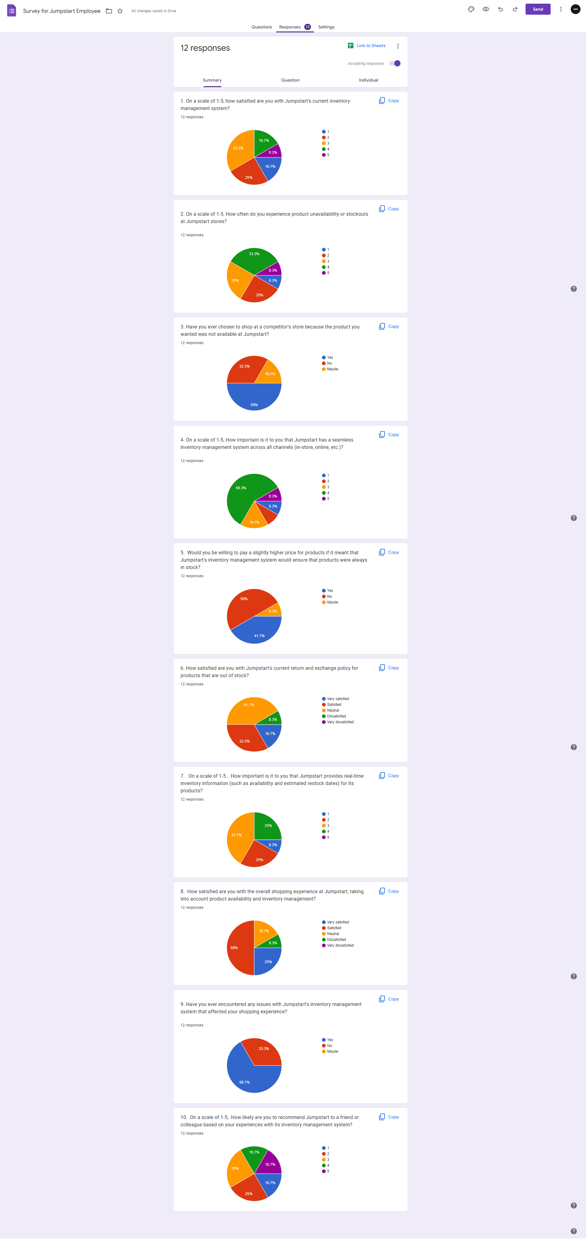
8. **Collect and analyze results:** this would be in the form of Graphs (pie charts or bar graphs)

# Project Part (Part II)

## Project Proposal

## Project Objective

Inventory management is a critical aspect of any retail business, and Jumpstart is no exception. As a project manager at Aceadora Tech, conducting research on inventory management for Jumpstart can help you identify the best practices and strategies to optimize their inventory management processes.

## Scope

The scope of this project includes researching and proposing a new inventory management system for Jumpstart. The proposed system will cover the following areas:

* Inventory tracking and monitoring
* Supplier management
* Sales and purchase order management
* Reporting and analytics
* User training and support
* Data migration from the old system to the new system

## Constraints

1. Limited availability of data:

Access to relevant data related to Jumpstart's inventory management may be limited or restricted, making it difficult to obtain a comprehensive understanding of the company's operations.

1. Time constraints:

Conducting thorough research on inventory management may require significant time and resources, which may be limited or constrained by other project or organizational requirements.

1. Budget constraints:

Conducting research on inventory management may require significant financial resources, including access to data and specialized software, which may be limited or constrained by the available budget.

1. Technical expertise:

Conducting research on inventory management may require technical expertise, including knowledge of specialized software, statistical analysis, and data management, which may be limited or constrained by the skills and expertise of the research team.

1. Organizational constraints:

The research may be subject to constraints related to organizational policies, procedures, or priorities, which may limit the scope or direction of the research.

## Assumptions

1. Jumpstart has a centralized inventory management system across all of its 750 stores.
2. The inventory data provided by Jumpstart is accurate and up-to-date.
3. The inventory management system currently used by Jumpstart is not optimized for remote or customer commerce.
4. The proposed solution will be technically feasible and scalable for Jumpstart's current and future needs.
5. The proposed solution will result in improved inventory accuracy, reduced stockouts, and increased customer satisfaction.
6. Jumpstart will allocate the necessary resources and budget for the implementation of the proposed solution.
7. The proposed solution will not have any negative impact on the current business operations or customer experience.

## Project Environment

The Jumpstart platform needs a web server with at least 4 cores and 8 gigabytes of RAM, a database server with at least 2 cores and 4 gigabytes of RAM, and a load balancer to split traffic among several web servers.

The development environment consisted of VS Code as the code editor, Google Chrome as the browser for testing and debugging, and Postman API for testing the API endpoints. The data for the website is stored in a MongoDB database hosted on the MongoDB Atlas platform.

The programming languages used to create the website include HTML, CSS, JavaScript, and TypeScript. HTML is used to create the structure and content of the web pages, while CSS is used to style and layout the pages and JavaScript is used to add interactivity and dynamic behavior to the website.

The frontend framework used for this website is NextJS, which is a React-based framework that provides server-side rendering, automatic code splitting, and optimized performance. TailwindCSS was used as the CSS framework to provide pre-built styles and utilities that can be easily customized.

For the backend, ExpressJS was used as the Node.js framework to handle the API requests and responses. Mongoose was used as the object data modeling (ODM) library to interact with the MongoDB database and simplify the data access and manipulation.

## Project design

1. Flowchart

A flowchart is a diagram that shows how a system, computer algorithm, or process works. They are frequently used in many different fields to study, plan, improve, and communicate frequently complex processes in simple, understandable diagrams. Rectangles, ovals, diamonds, and possibly many other shapes are used in flowcharts, also known as flow charts, to indicate the type of step and connecting arrows to indicate flow and sequence.

**Flowchart User**

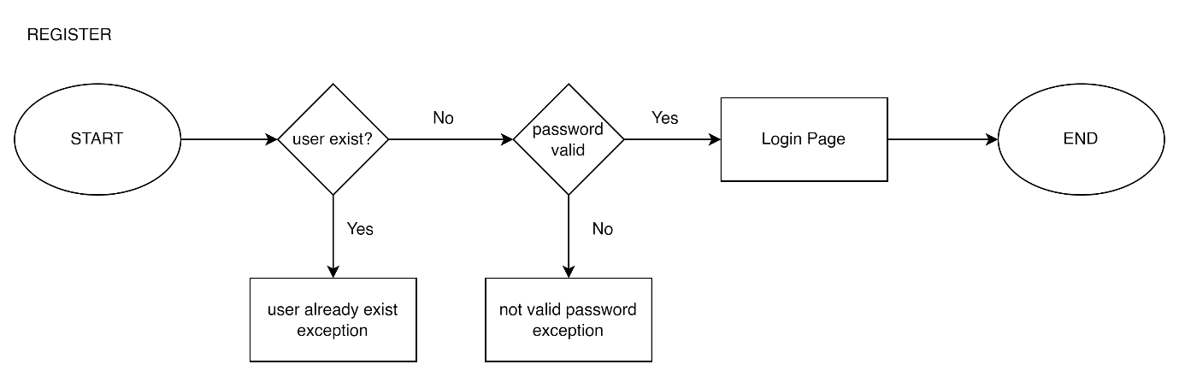

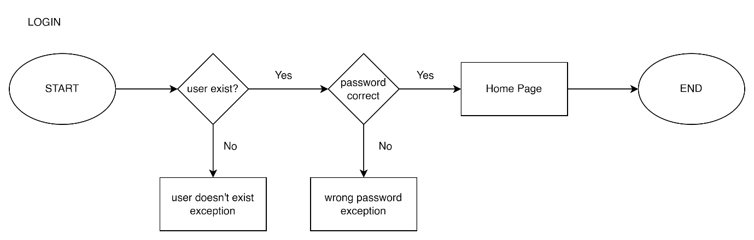

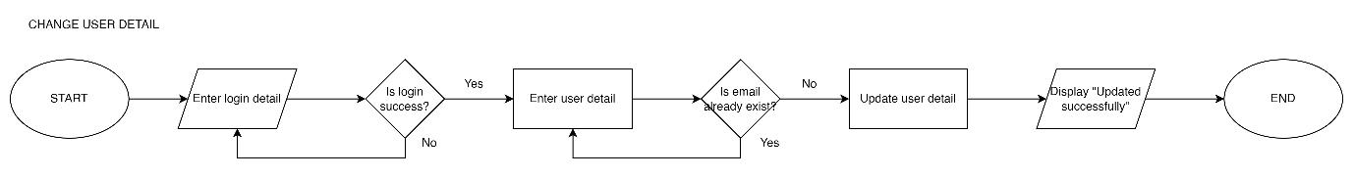

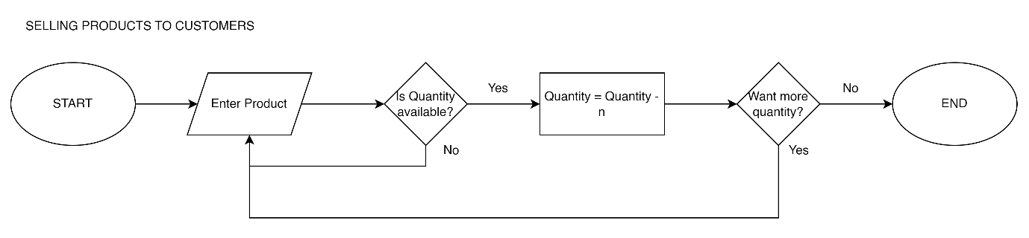

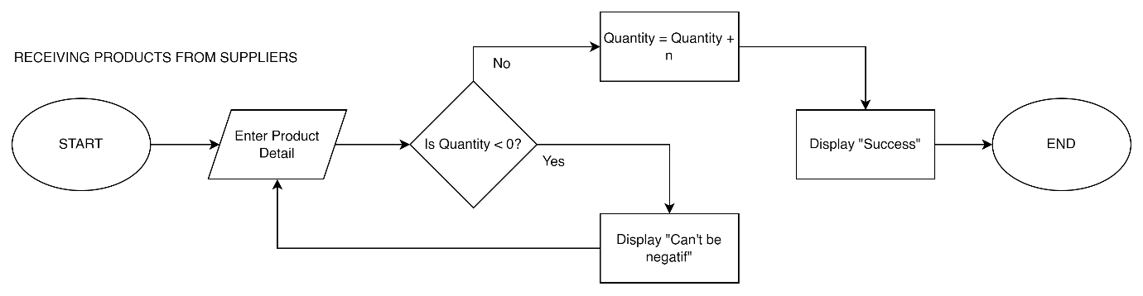

**Admin Flowchart**

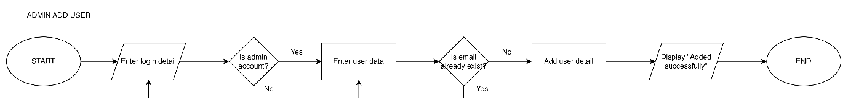

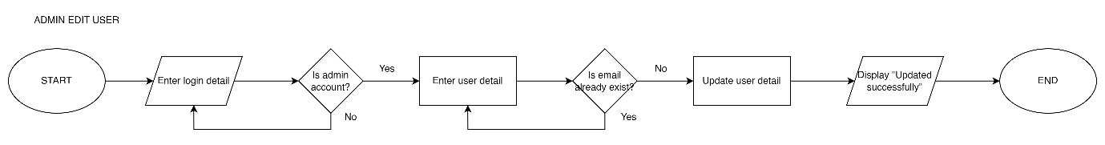

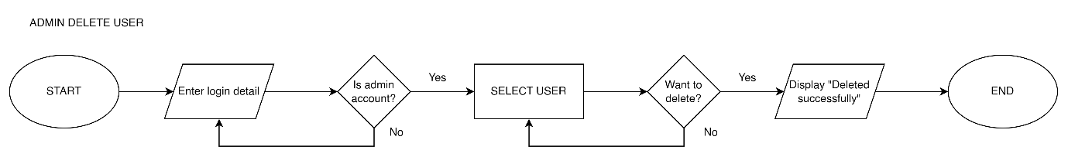

1. Wireframe

A website service can be designed structurally using wireframes. In order to layout content and functionality on a page while taking into account user needs and user journeys, a wireframe is frequently used. Before adding visual design and content to a page, the basic structure of the page is established using wireframes early in the development process.



Landing Page



About Us

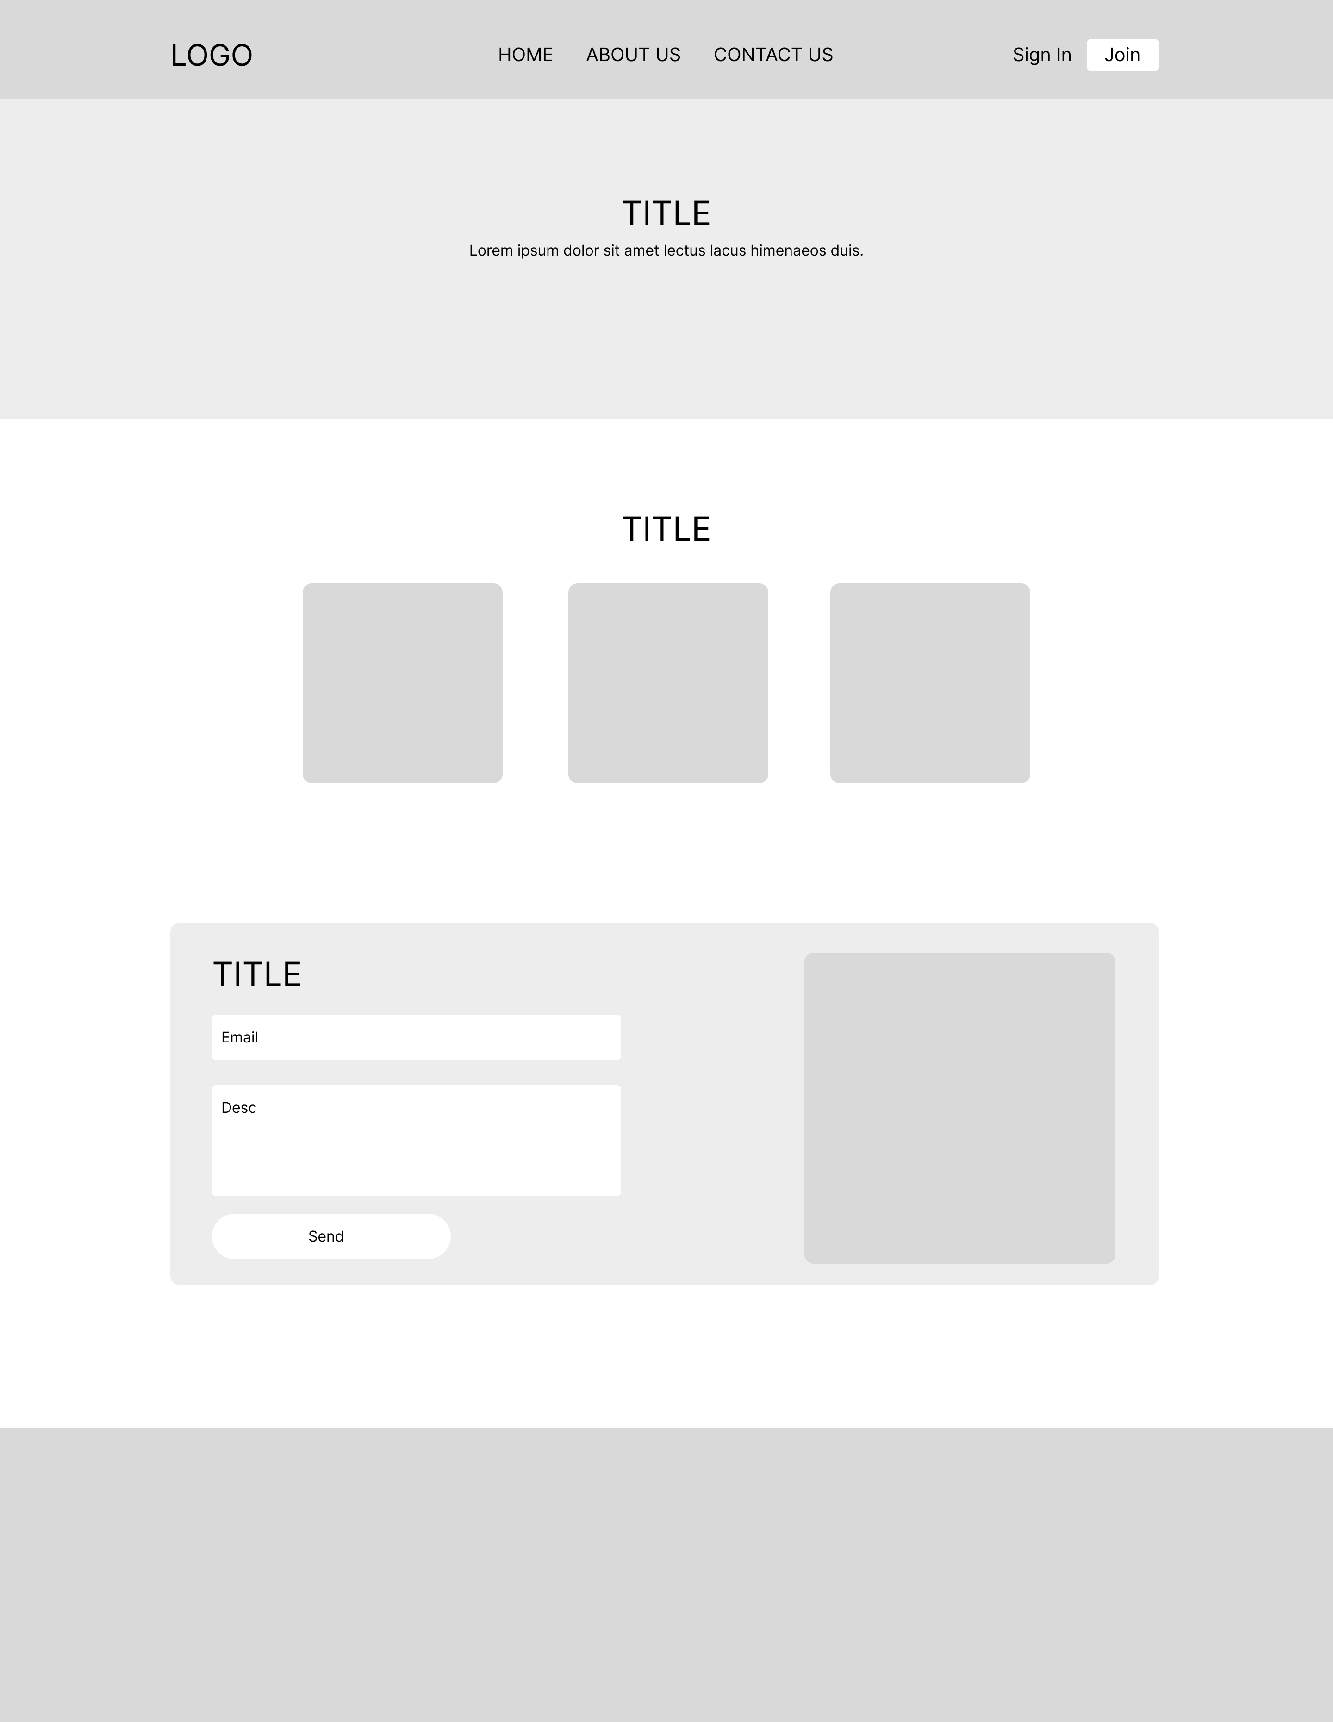

Contact Us

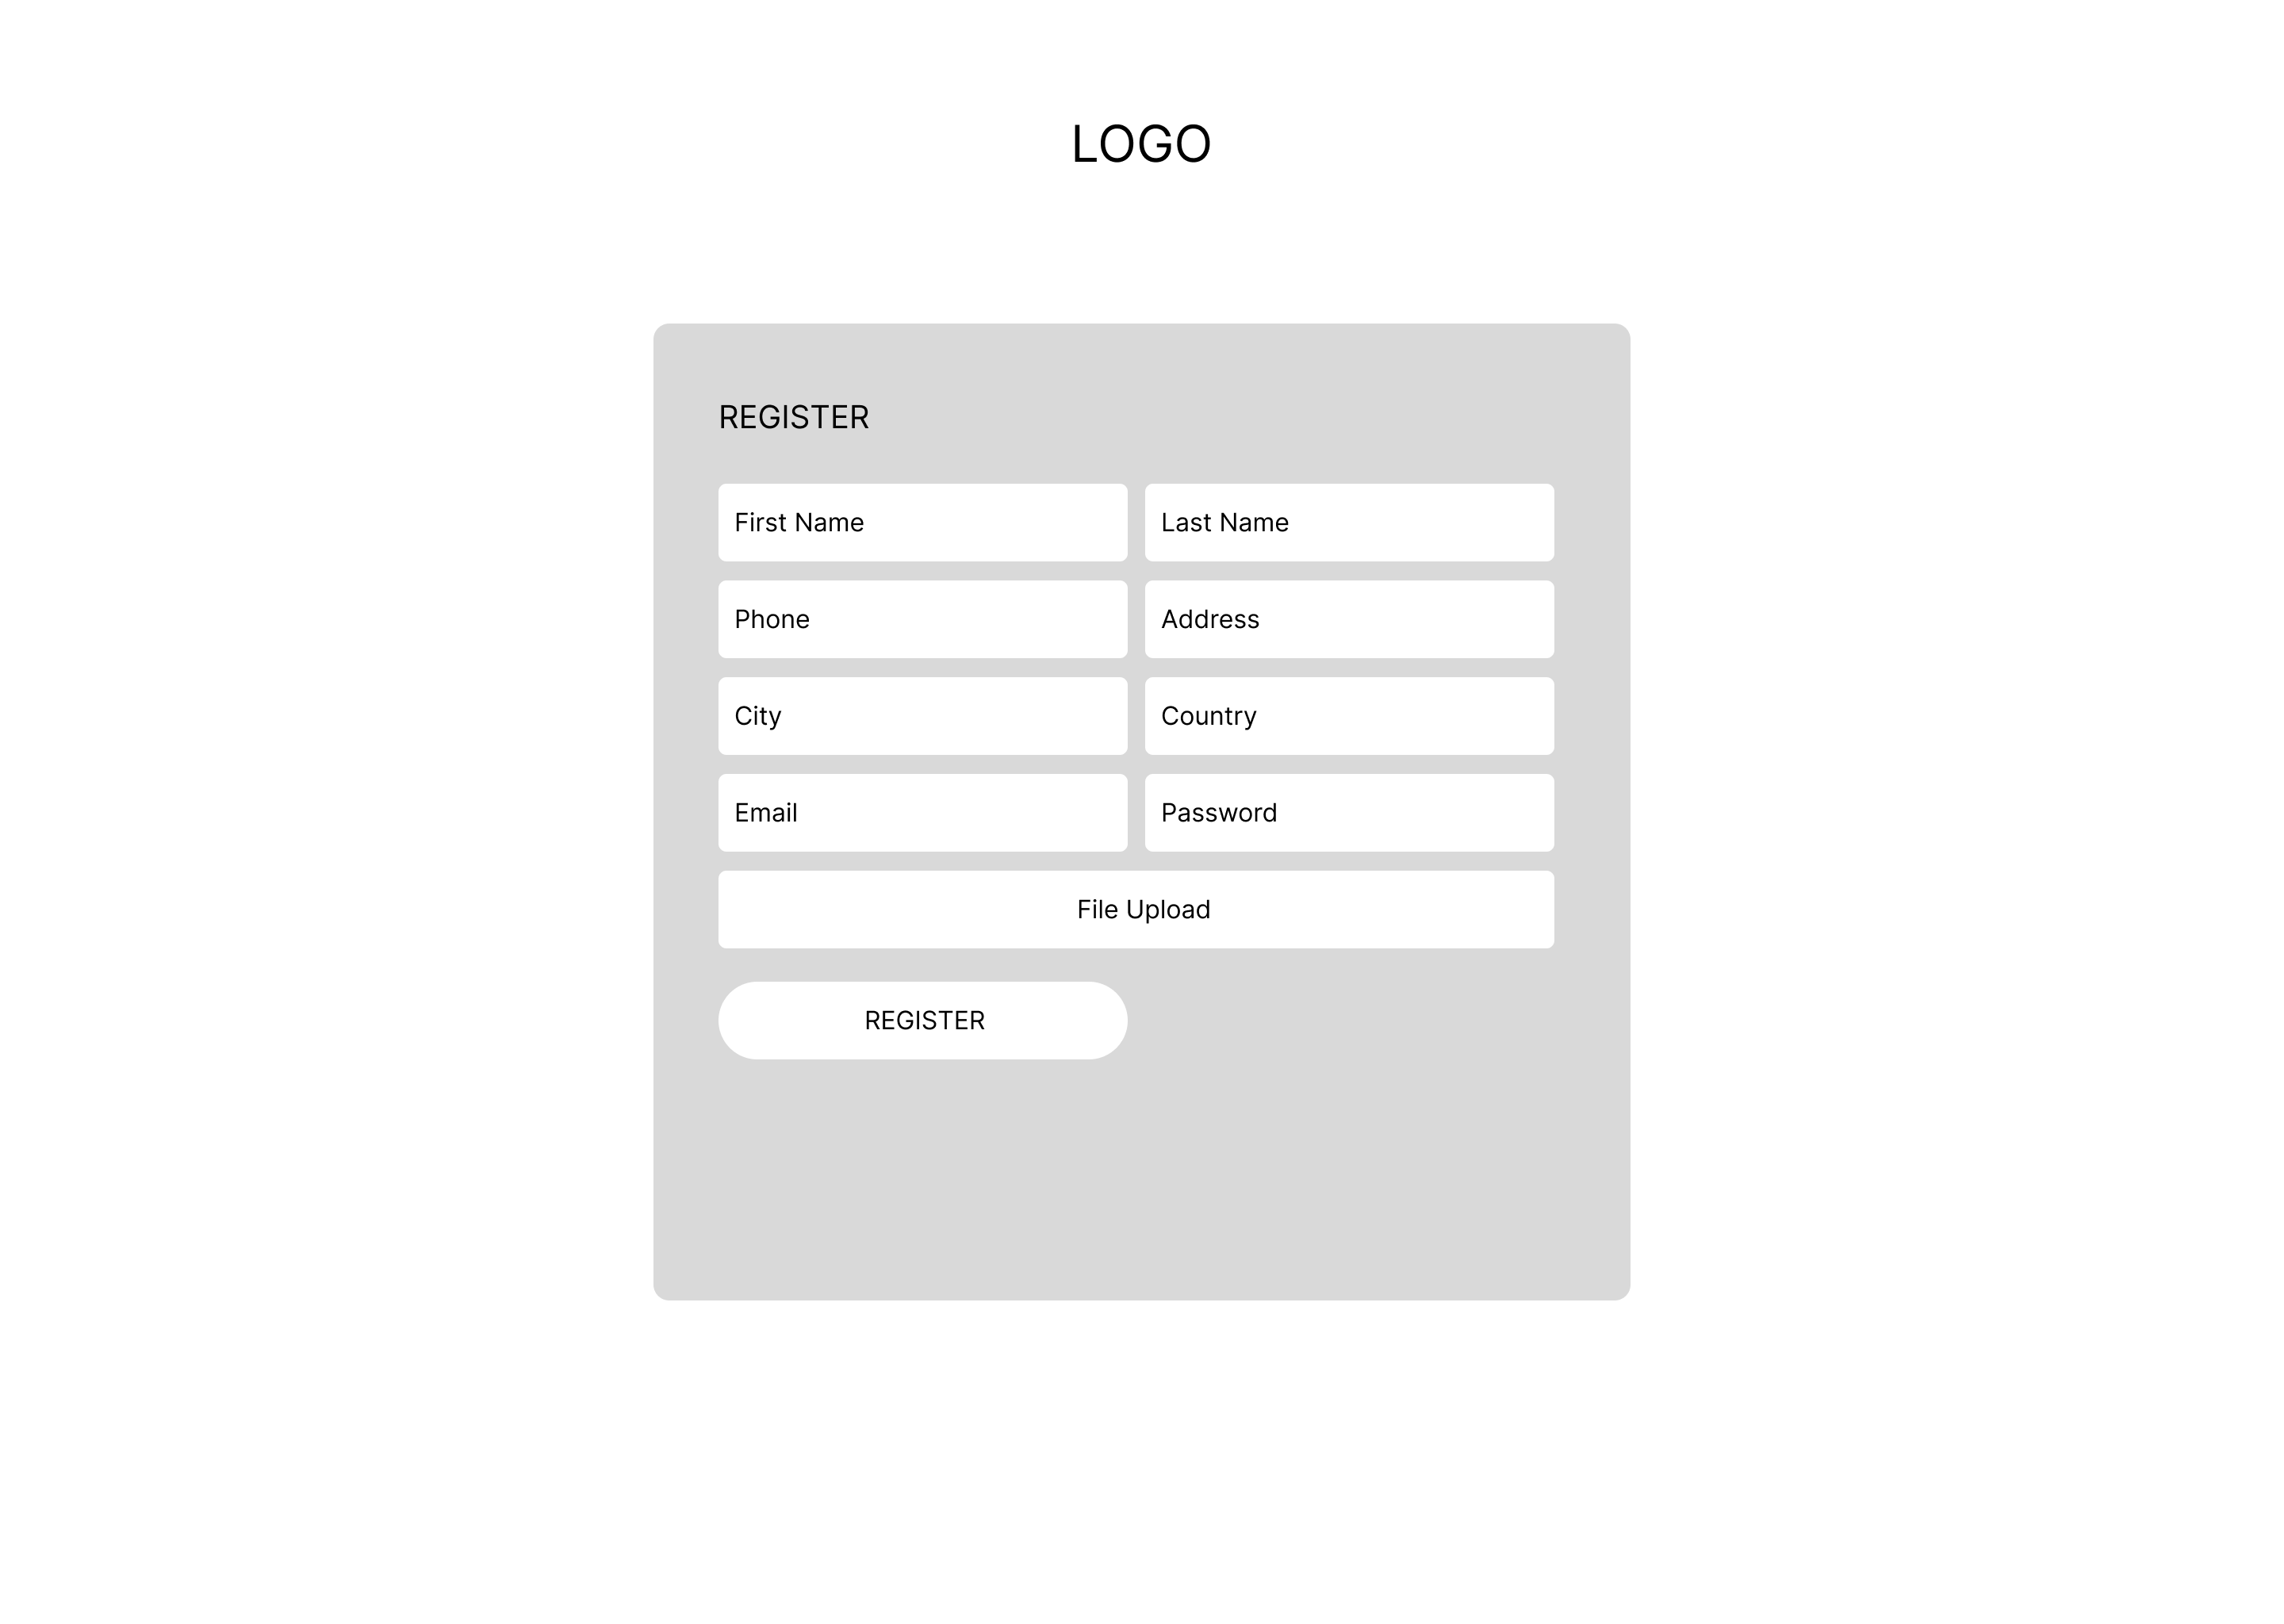

Register Page

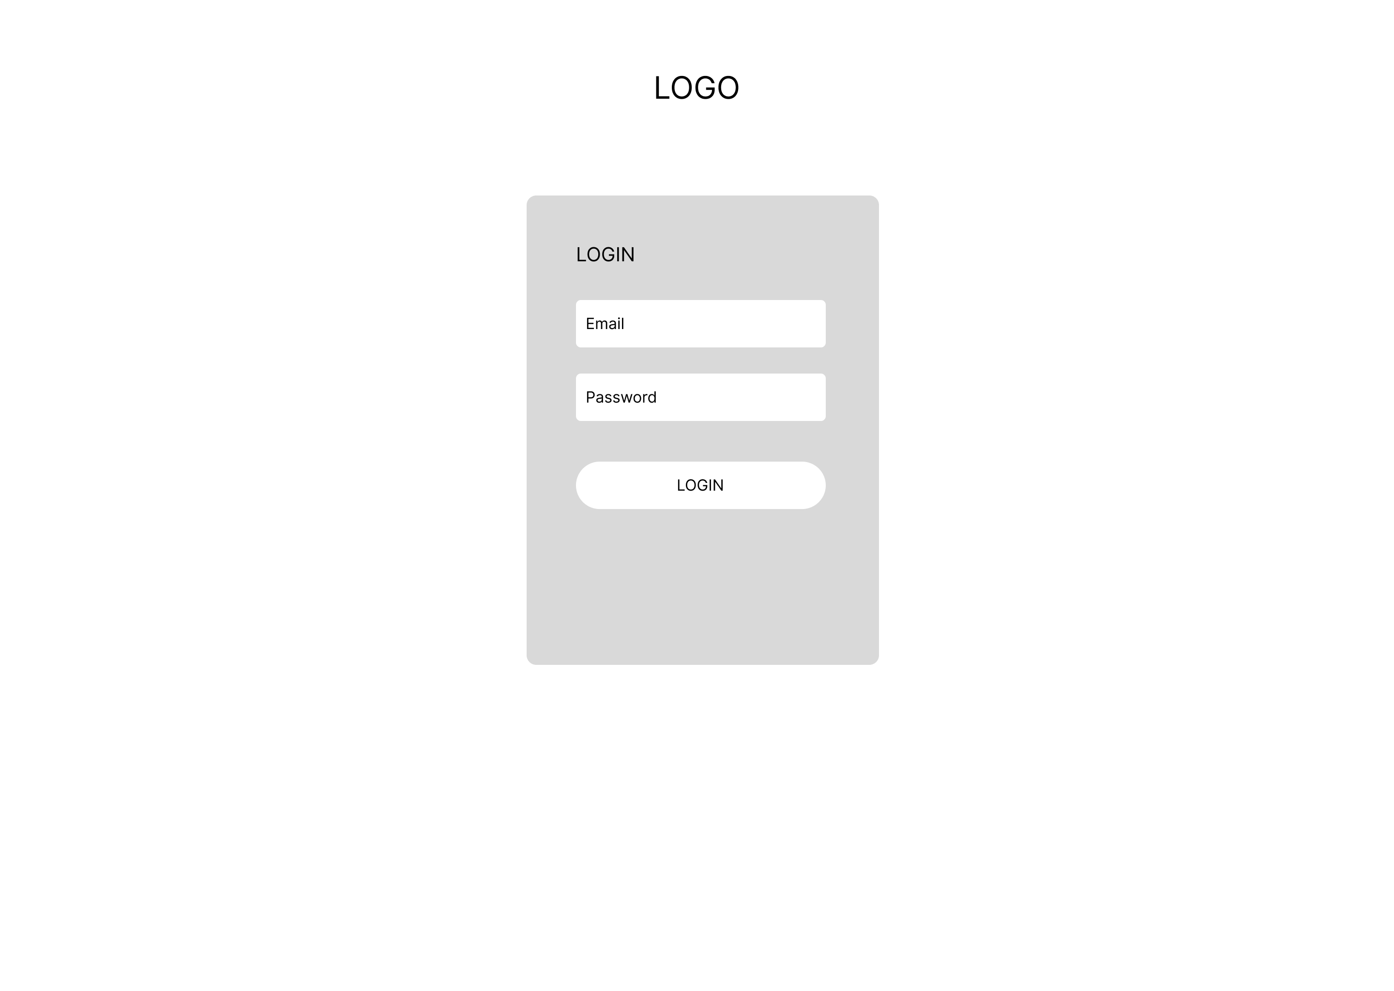

Login Page

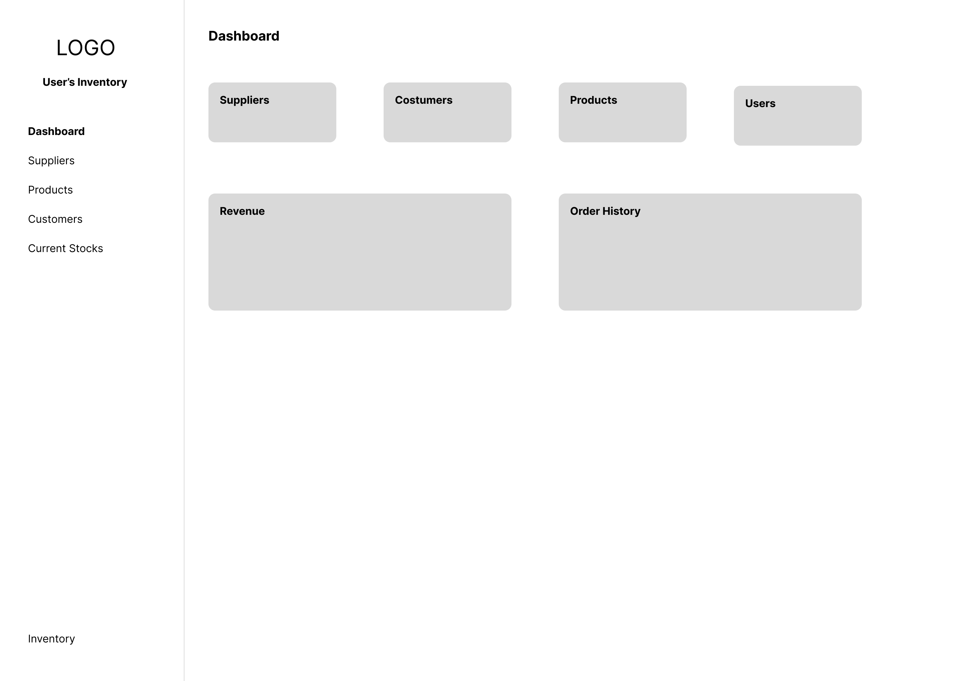

User Dashboard Page

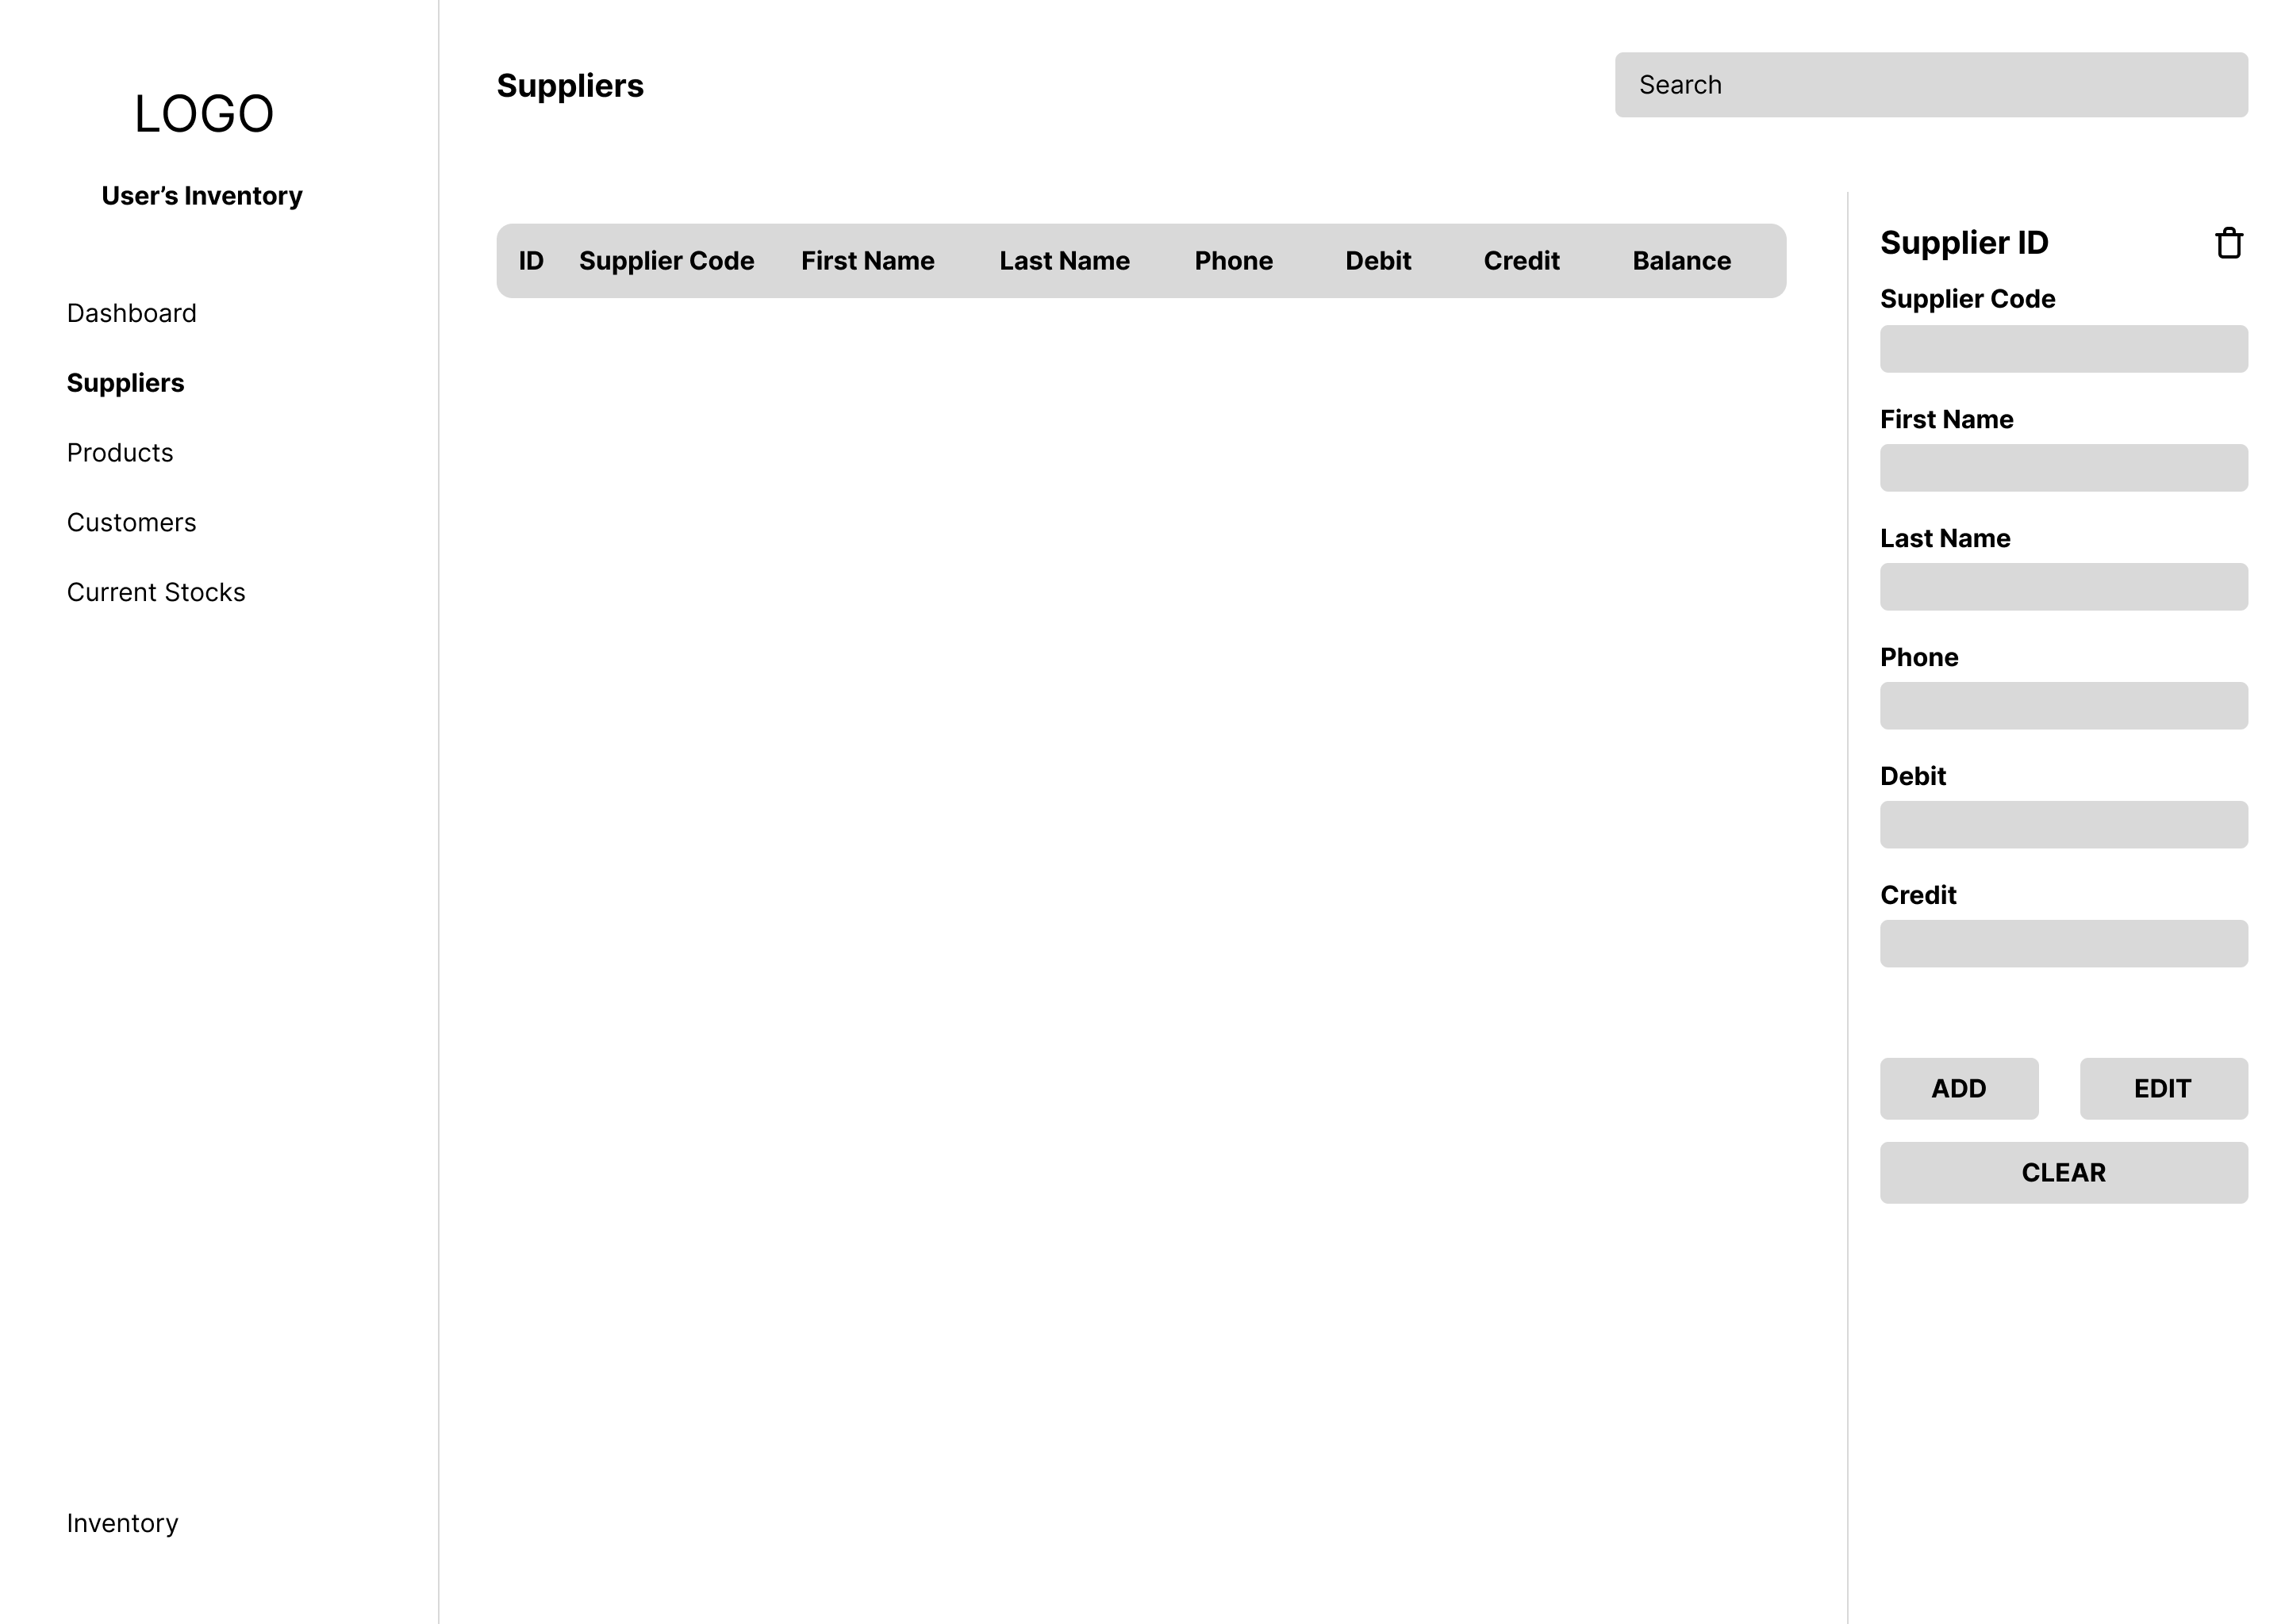

User Suppliers Page

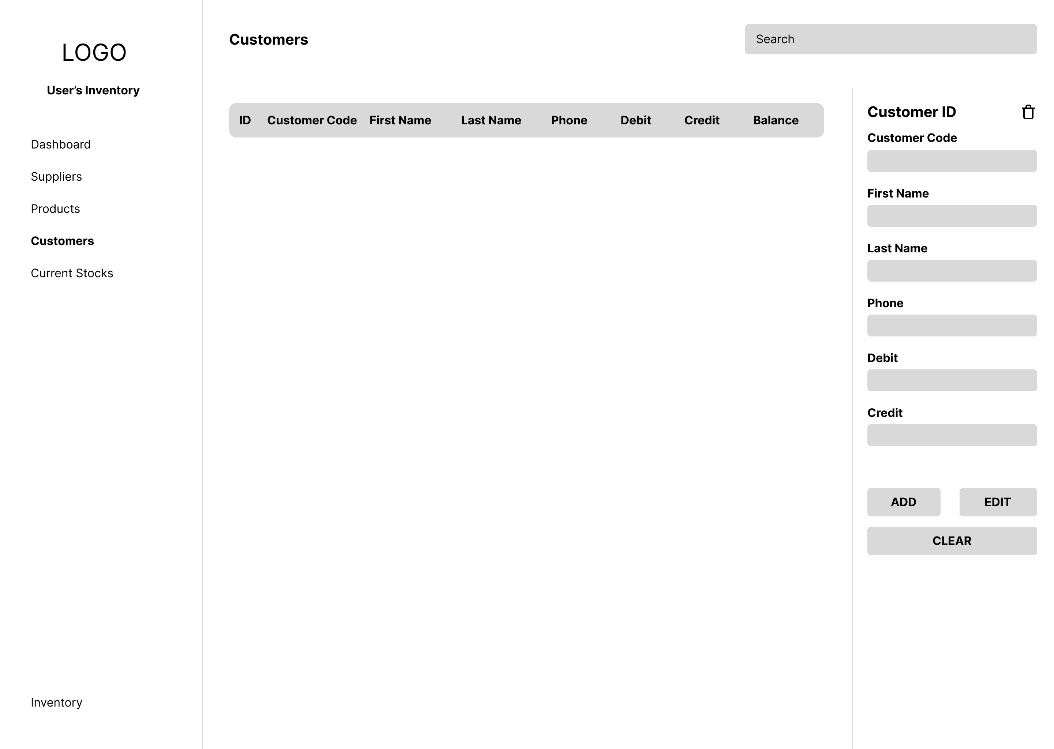

User Customers Page

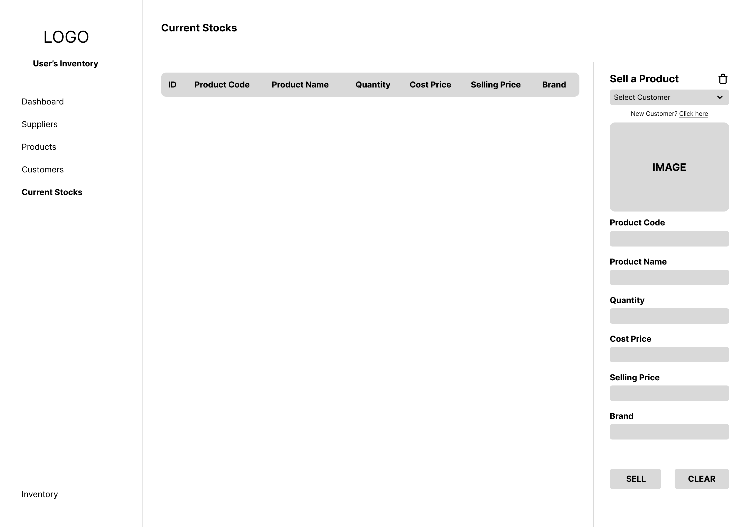

User Current Stocks Page

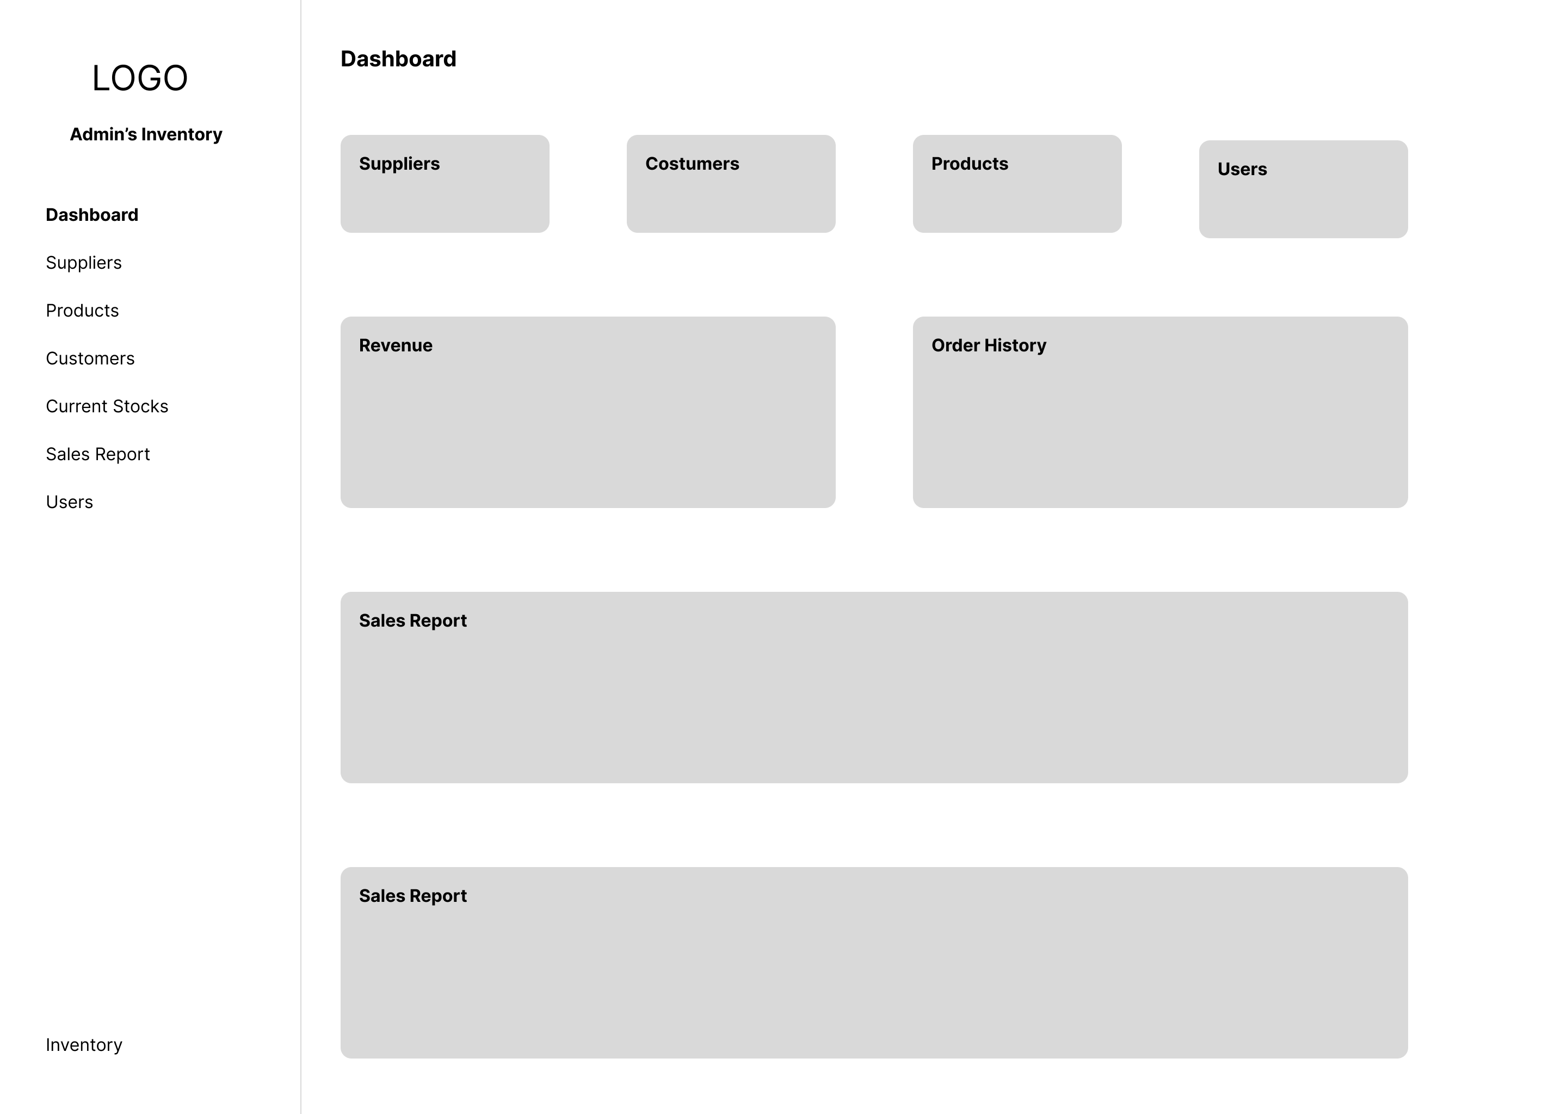

Admin Dashboard Page

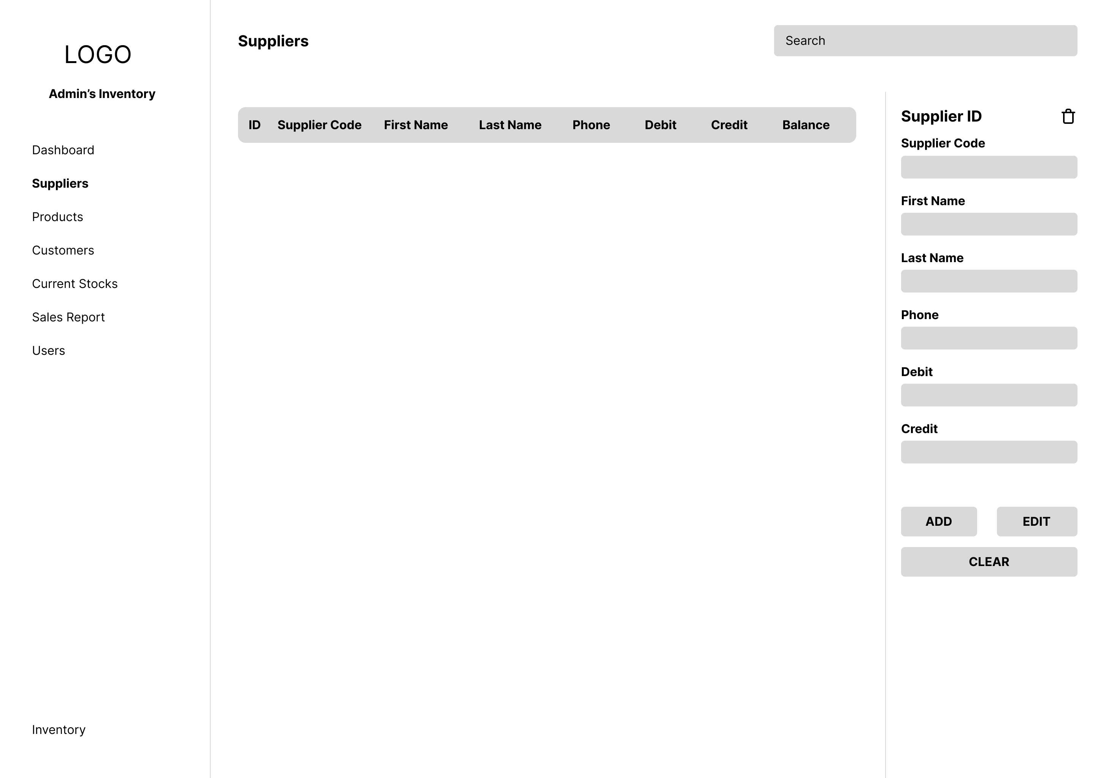

Admin Suppliers Page

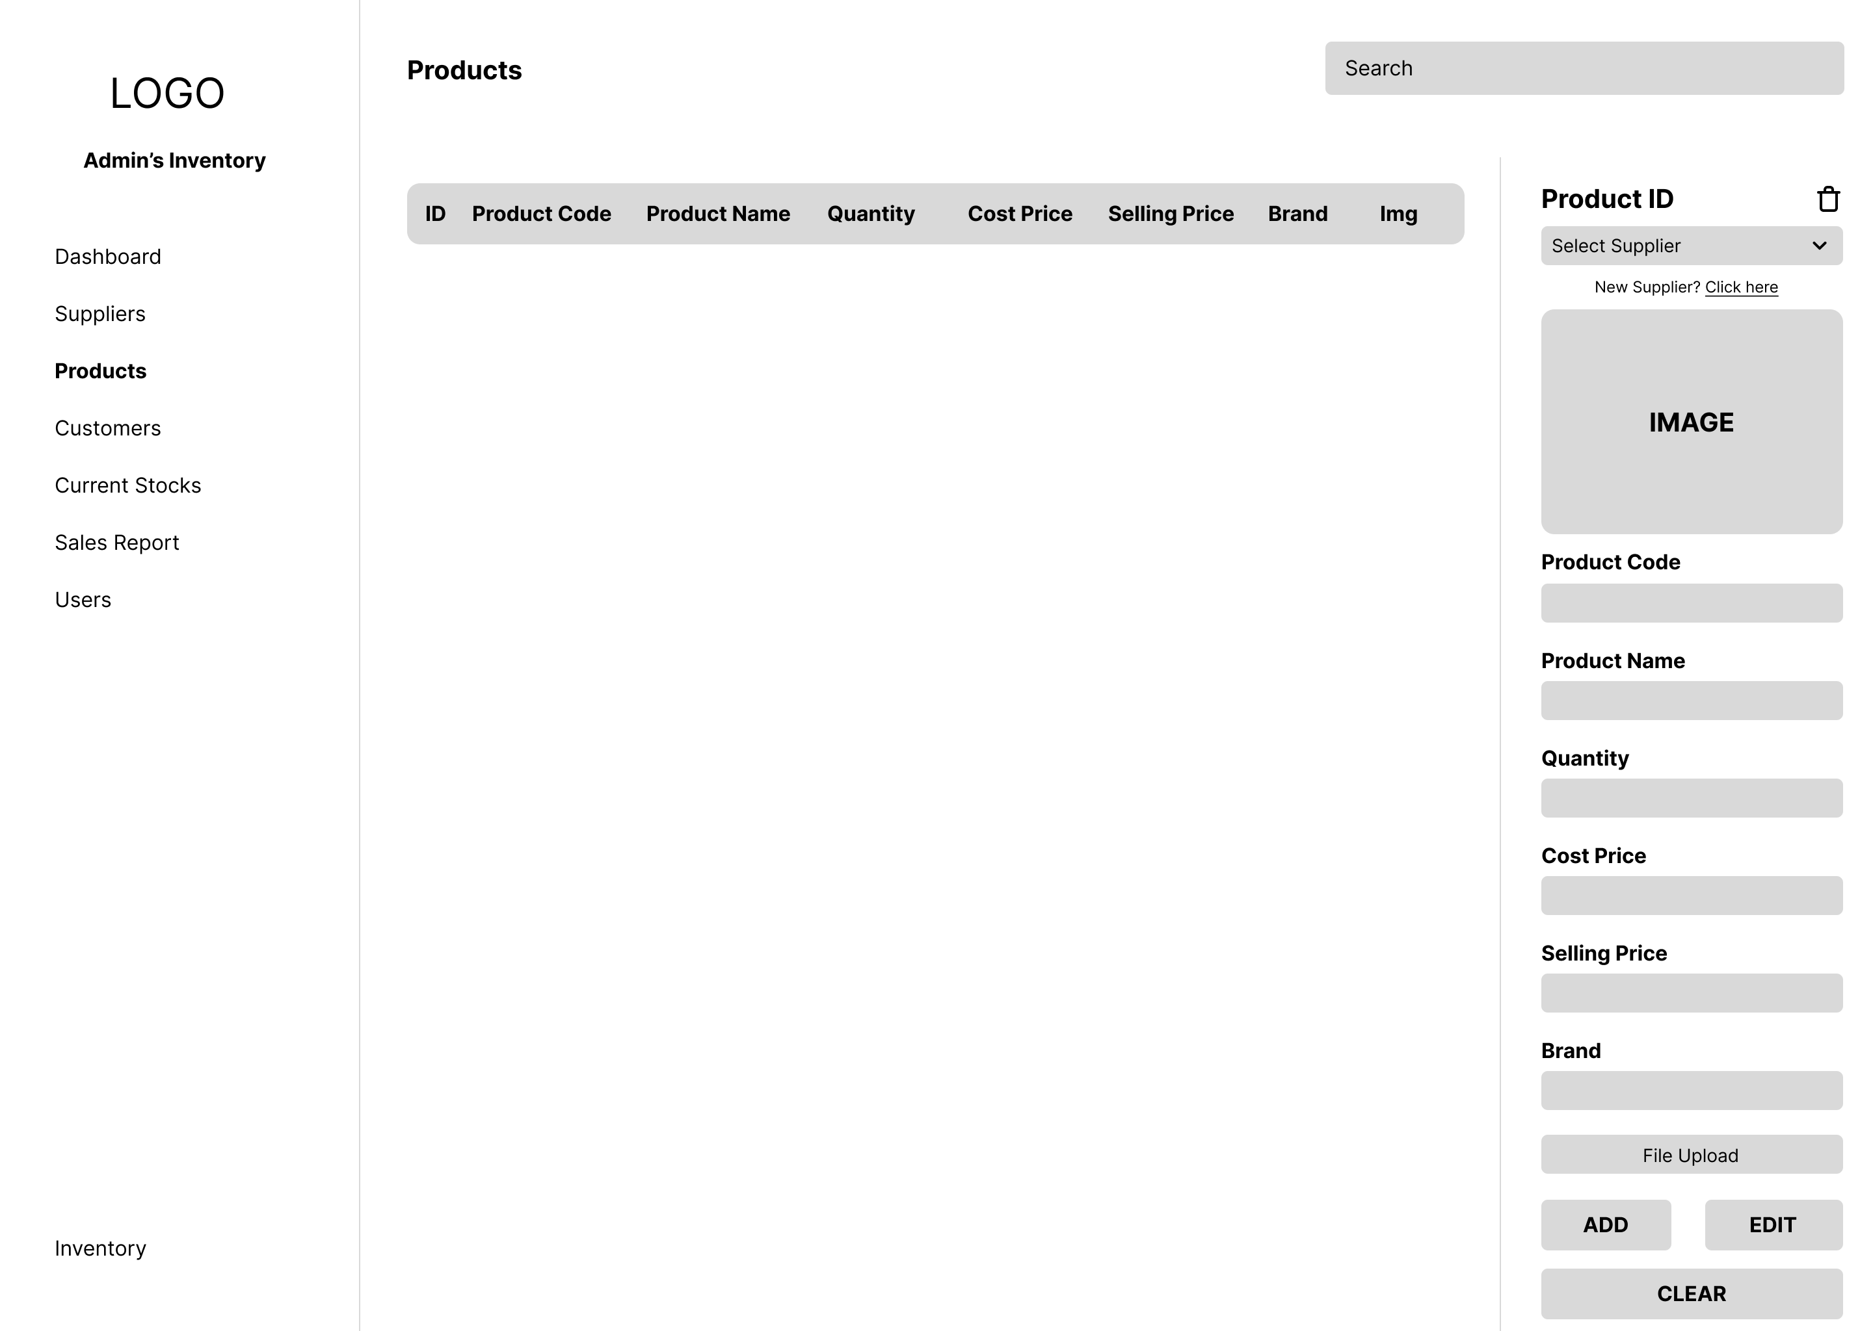

Admin Products Page

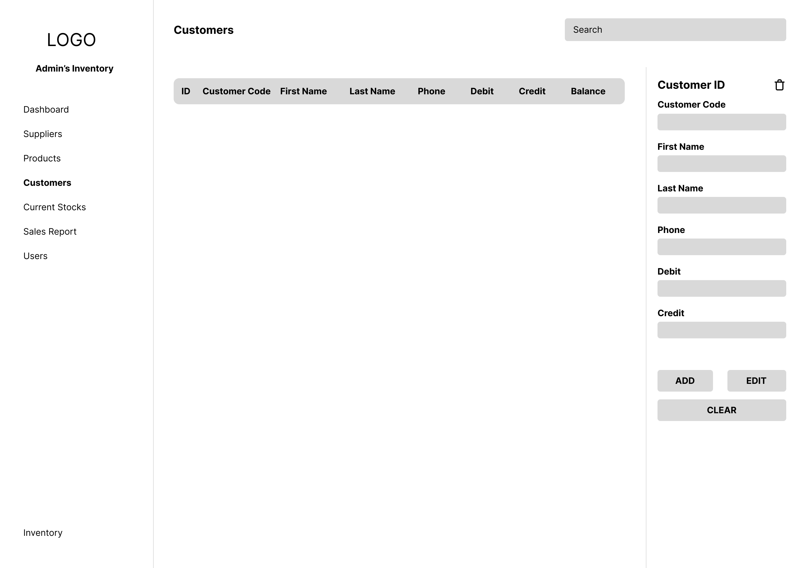

Admin Costumers Page

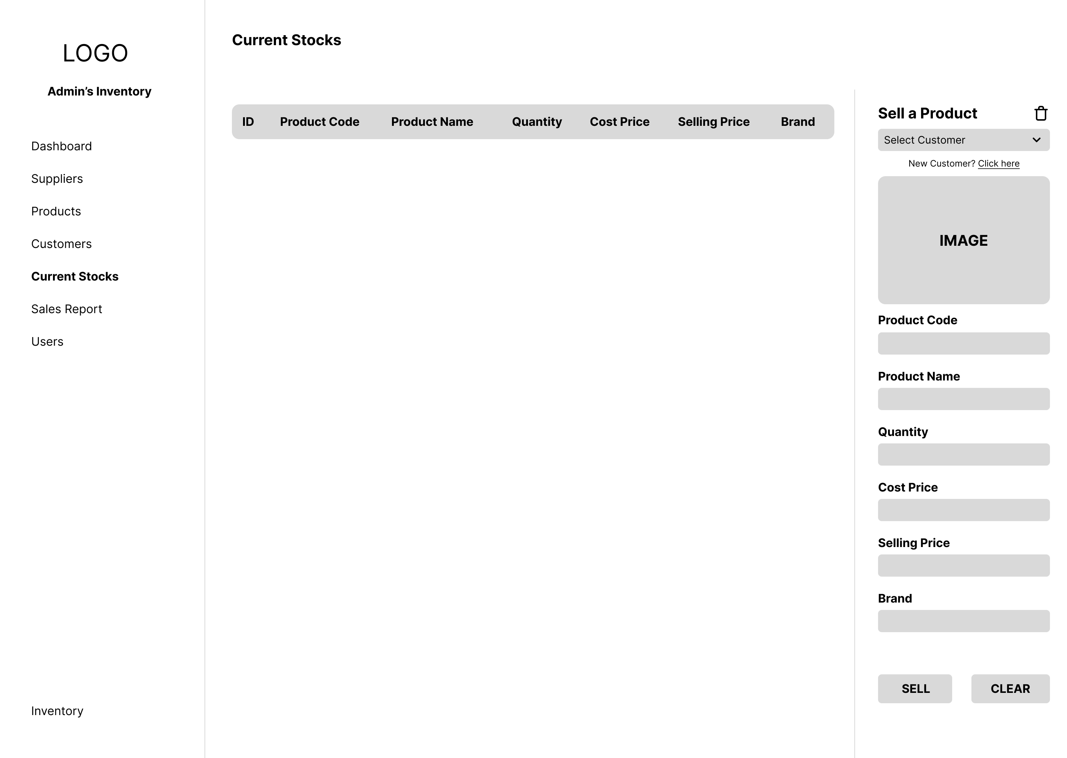

Admin Current Stocks Page

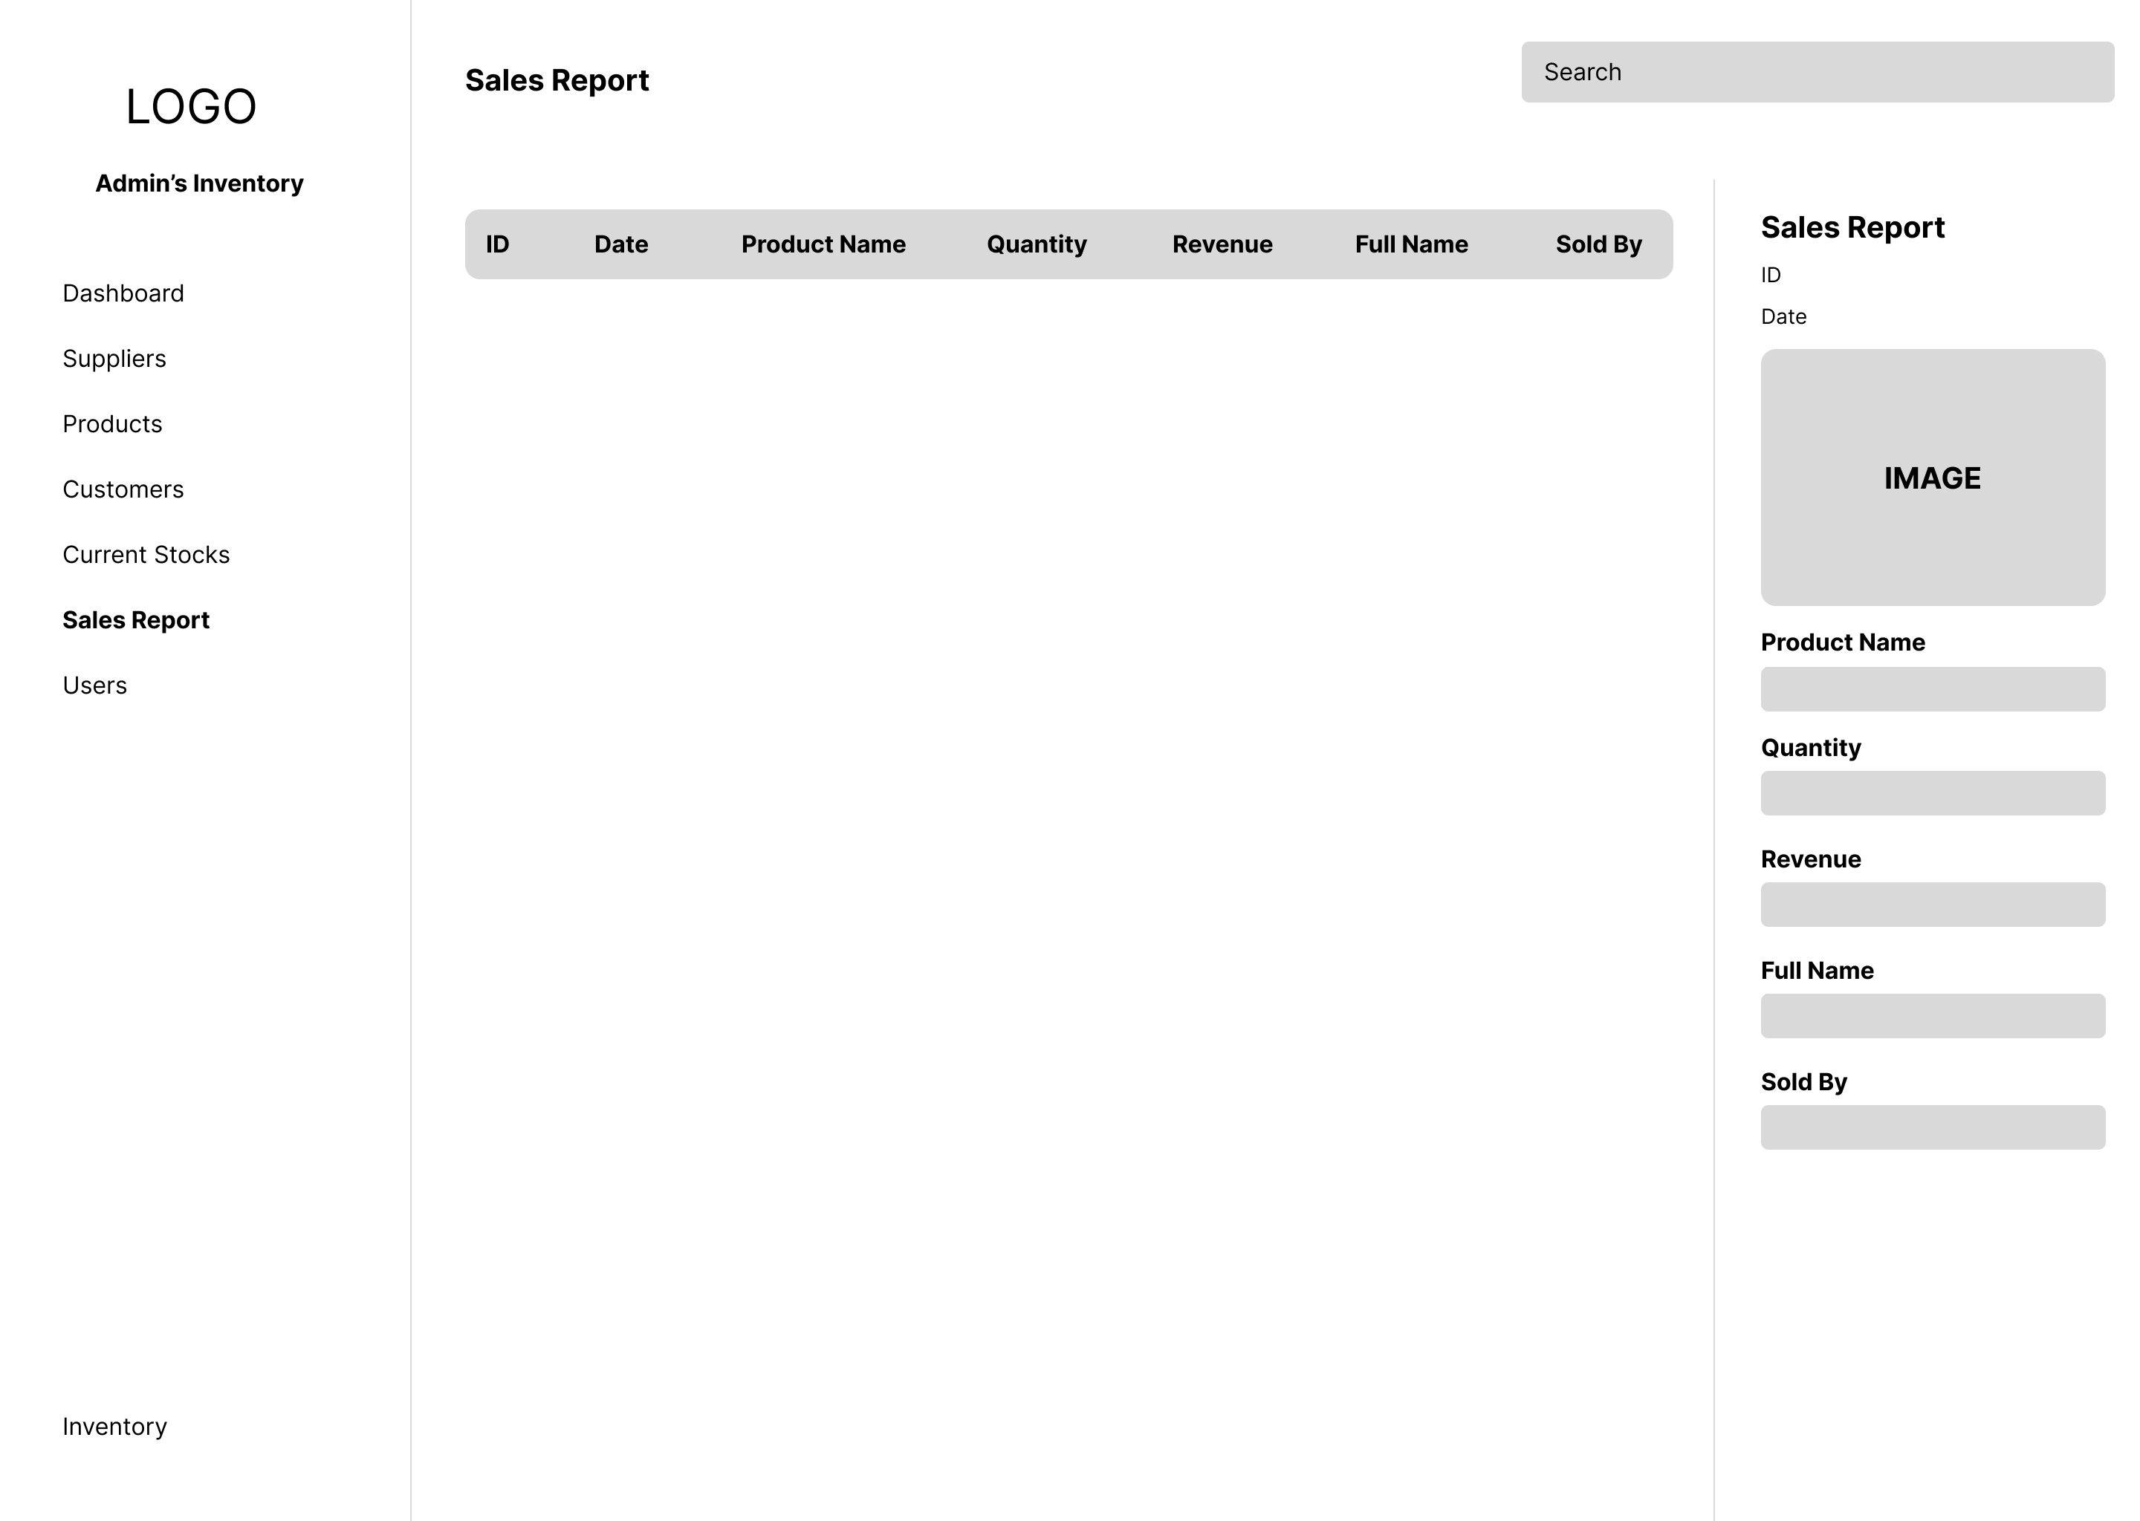

Admin Sales Report Page

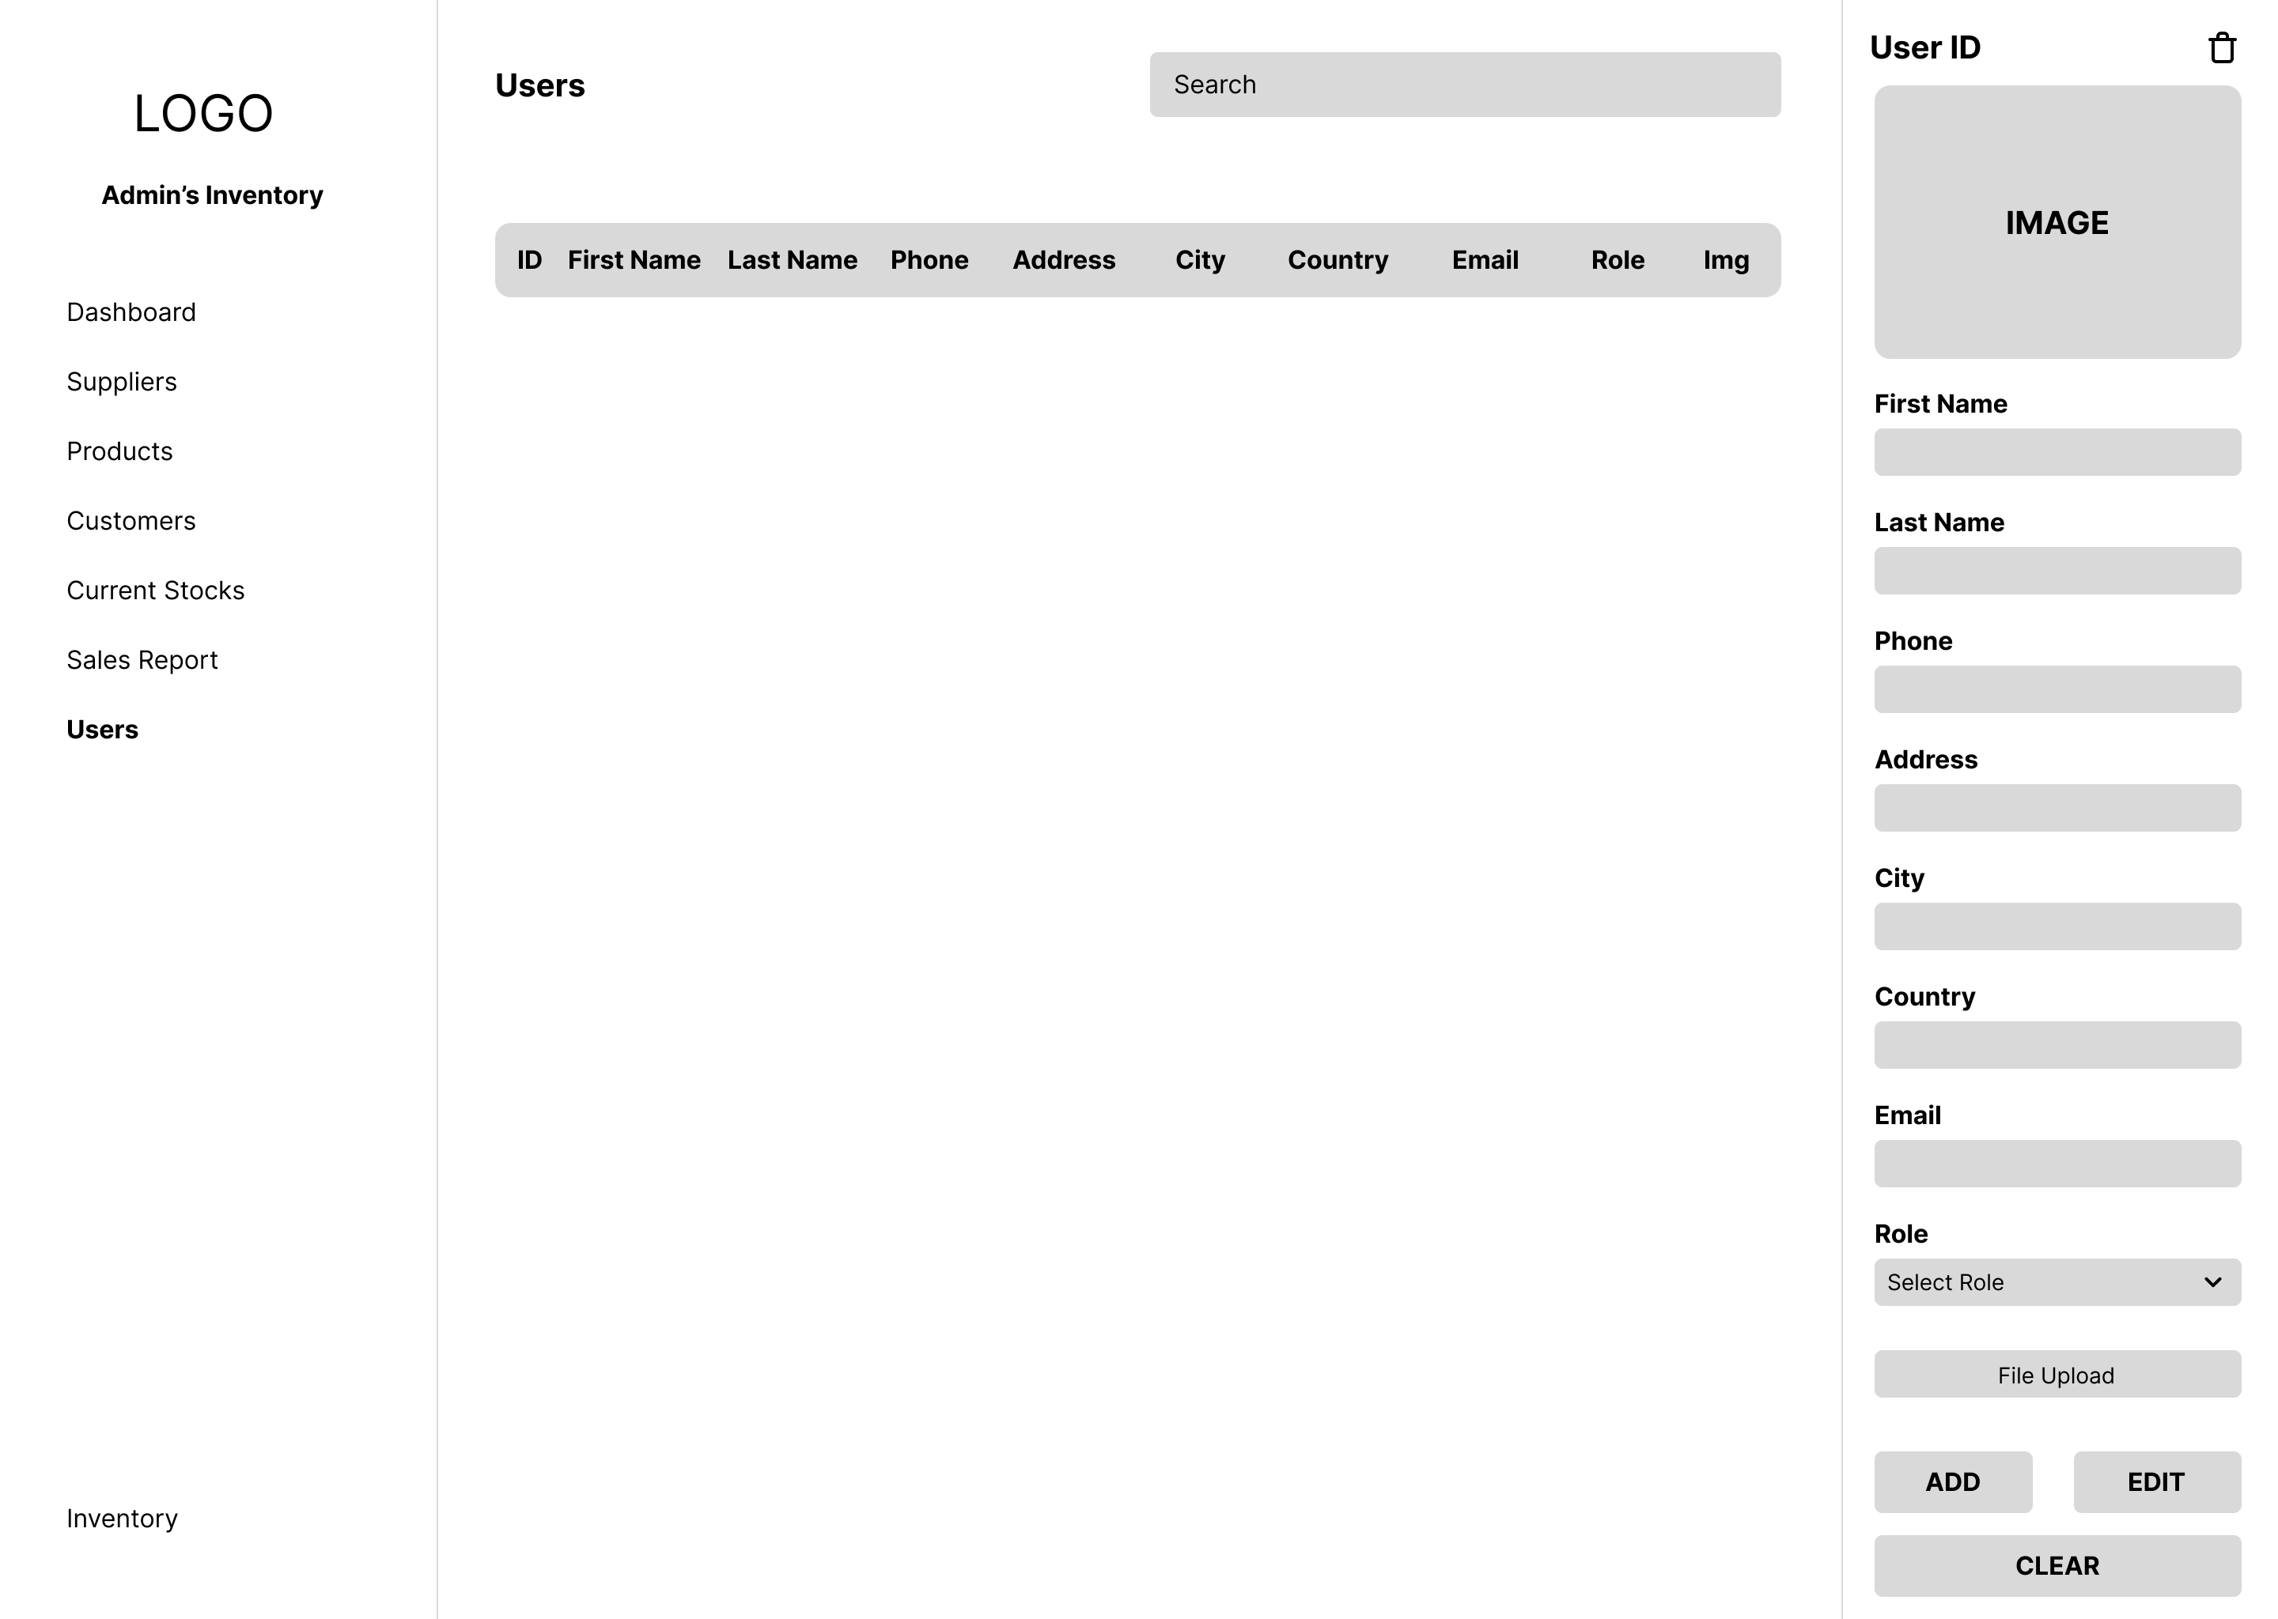

Admin Manage Users Page

1. Storyboard

A storyboard is a straightforward illustration of a design undertaking. Storyboards can be used by any designer, including those in the film, fashion, design, and digital development industries. What exactly does a storyboard in web design mean? A storyboard website design is a quick digital rendering of the look and behavior of a website.

**Storyboard**

**Login   
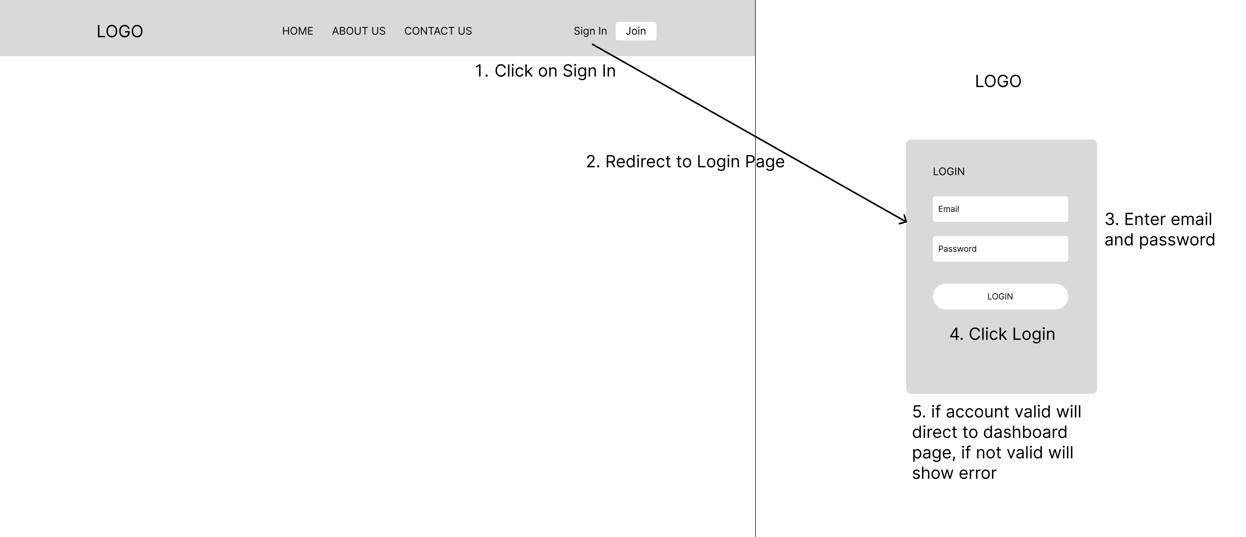**

**Register**

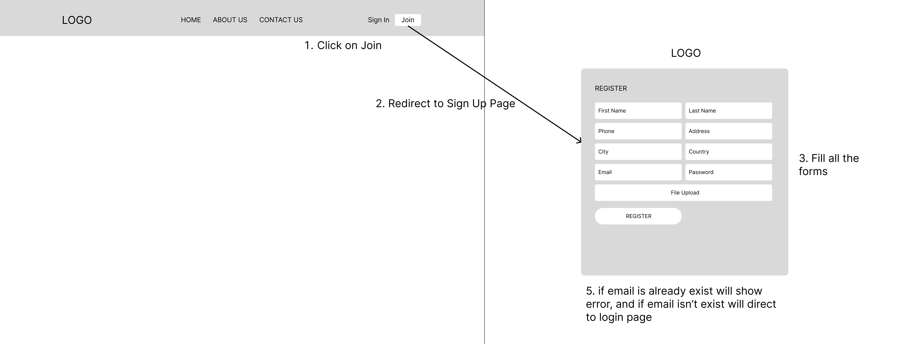

**Add Product  
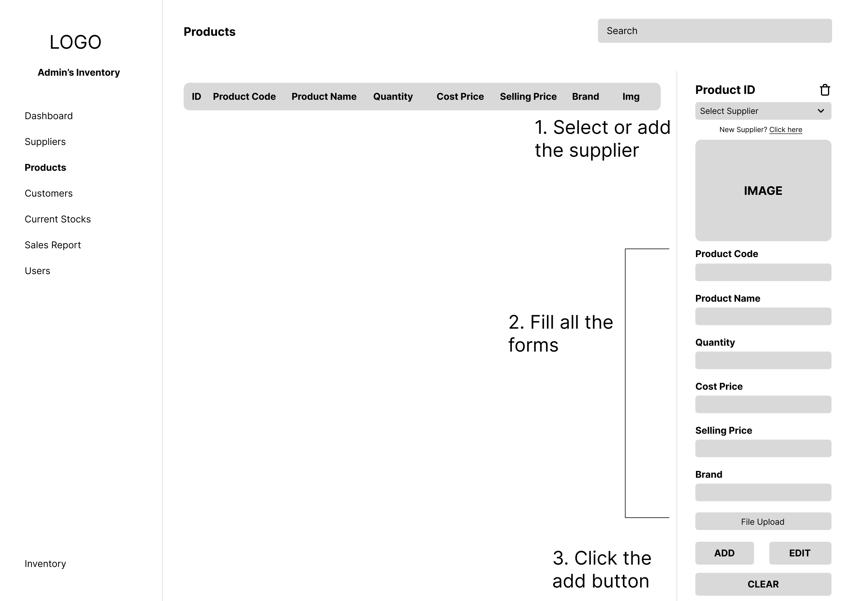**

**Edit Product  
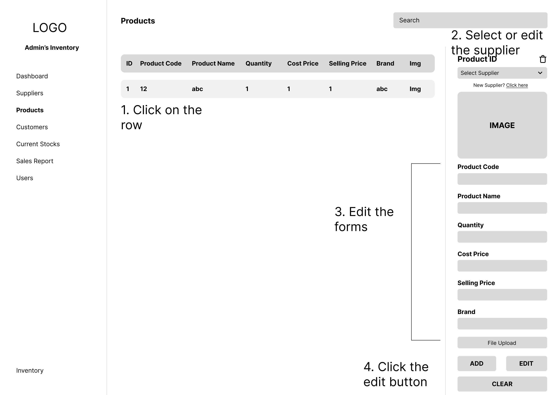  
  
Delete Product  
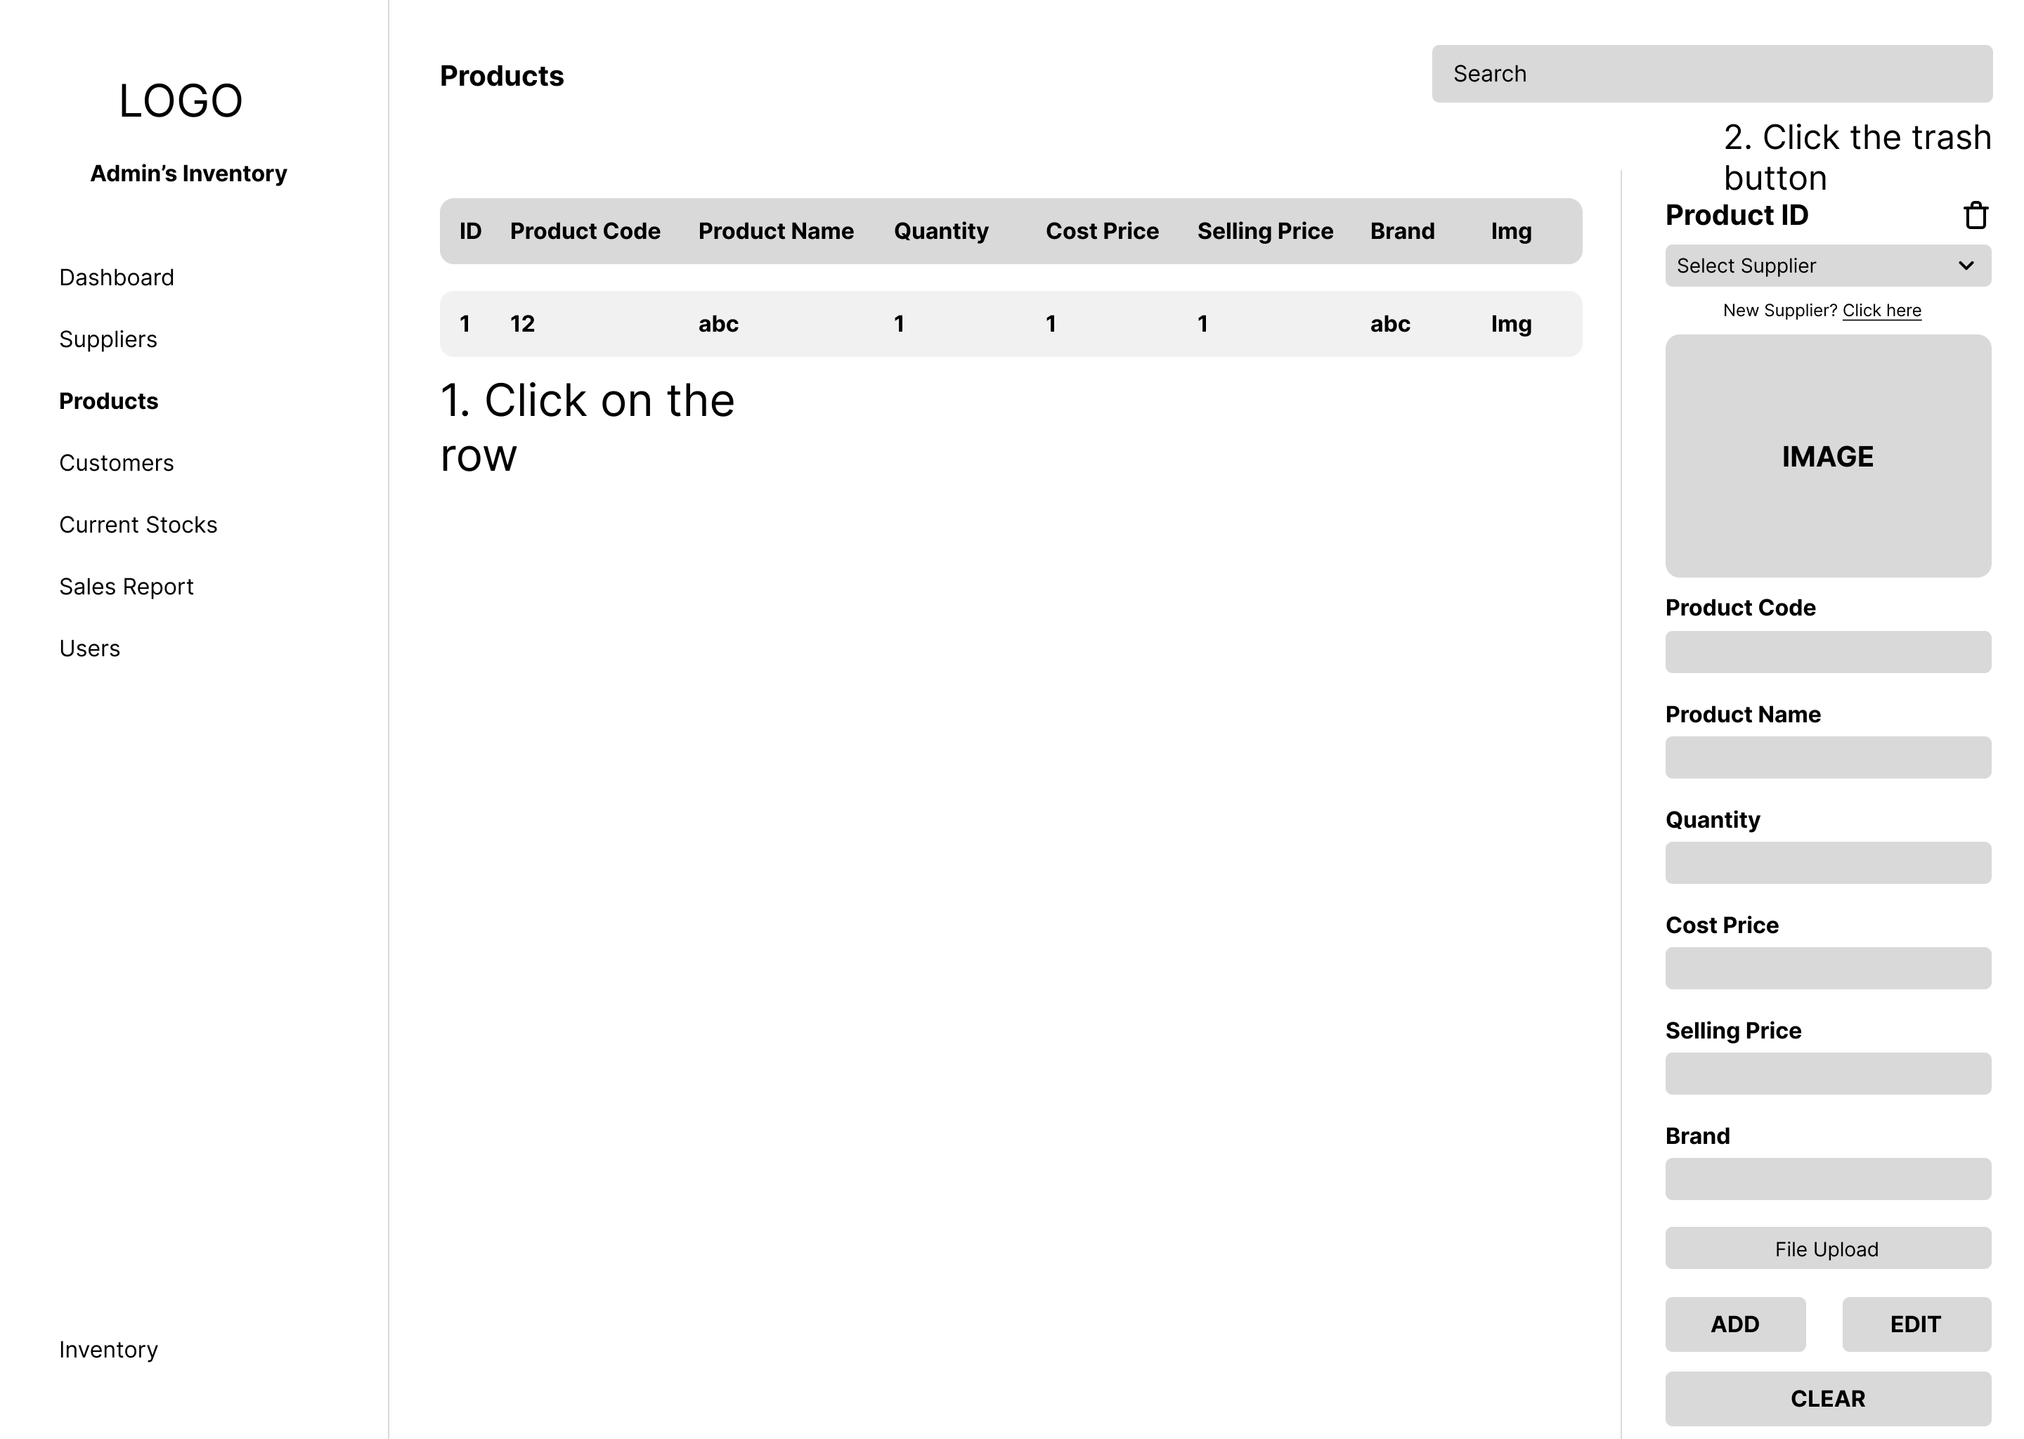**

**Admin Story Board**

**Add User  
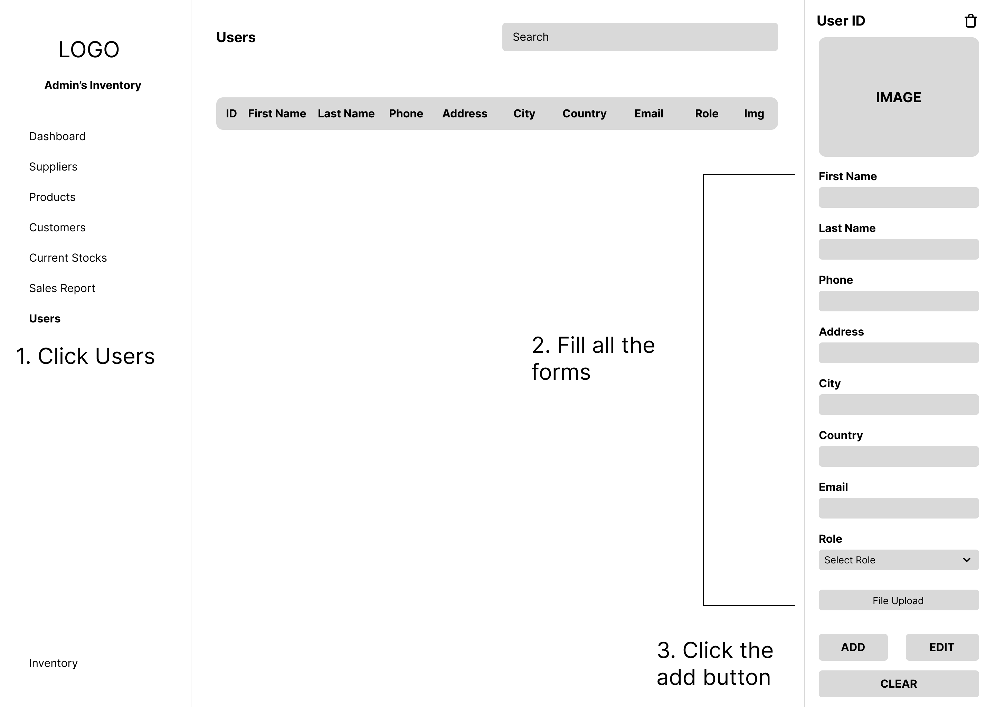**

**Edit User  
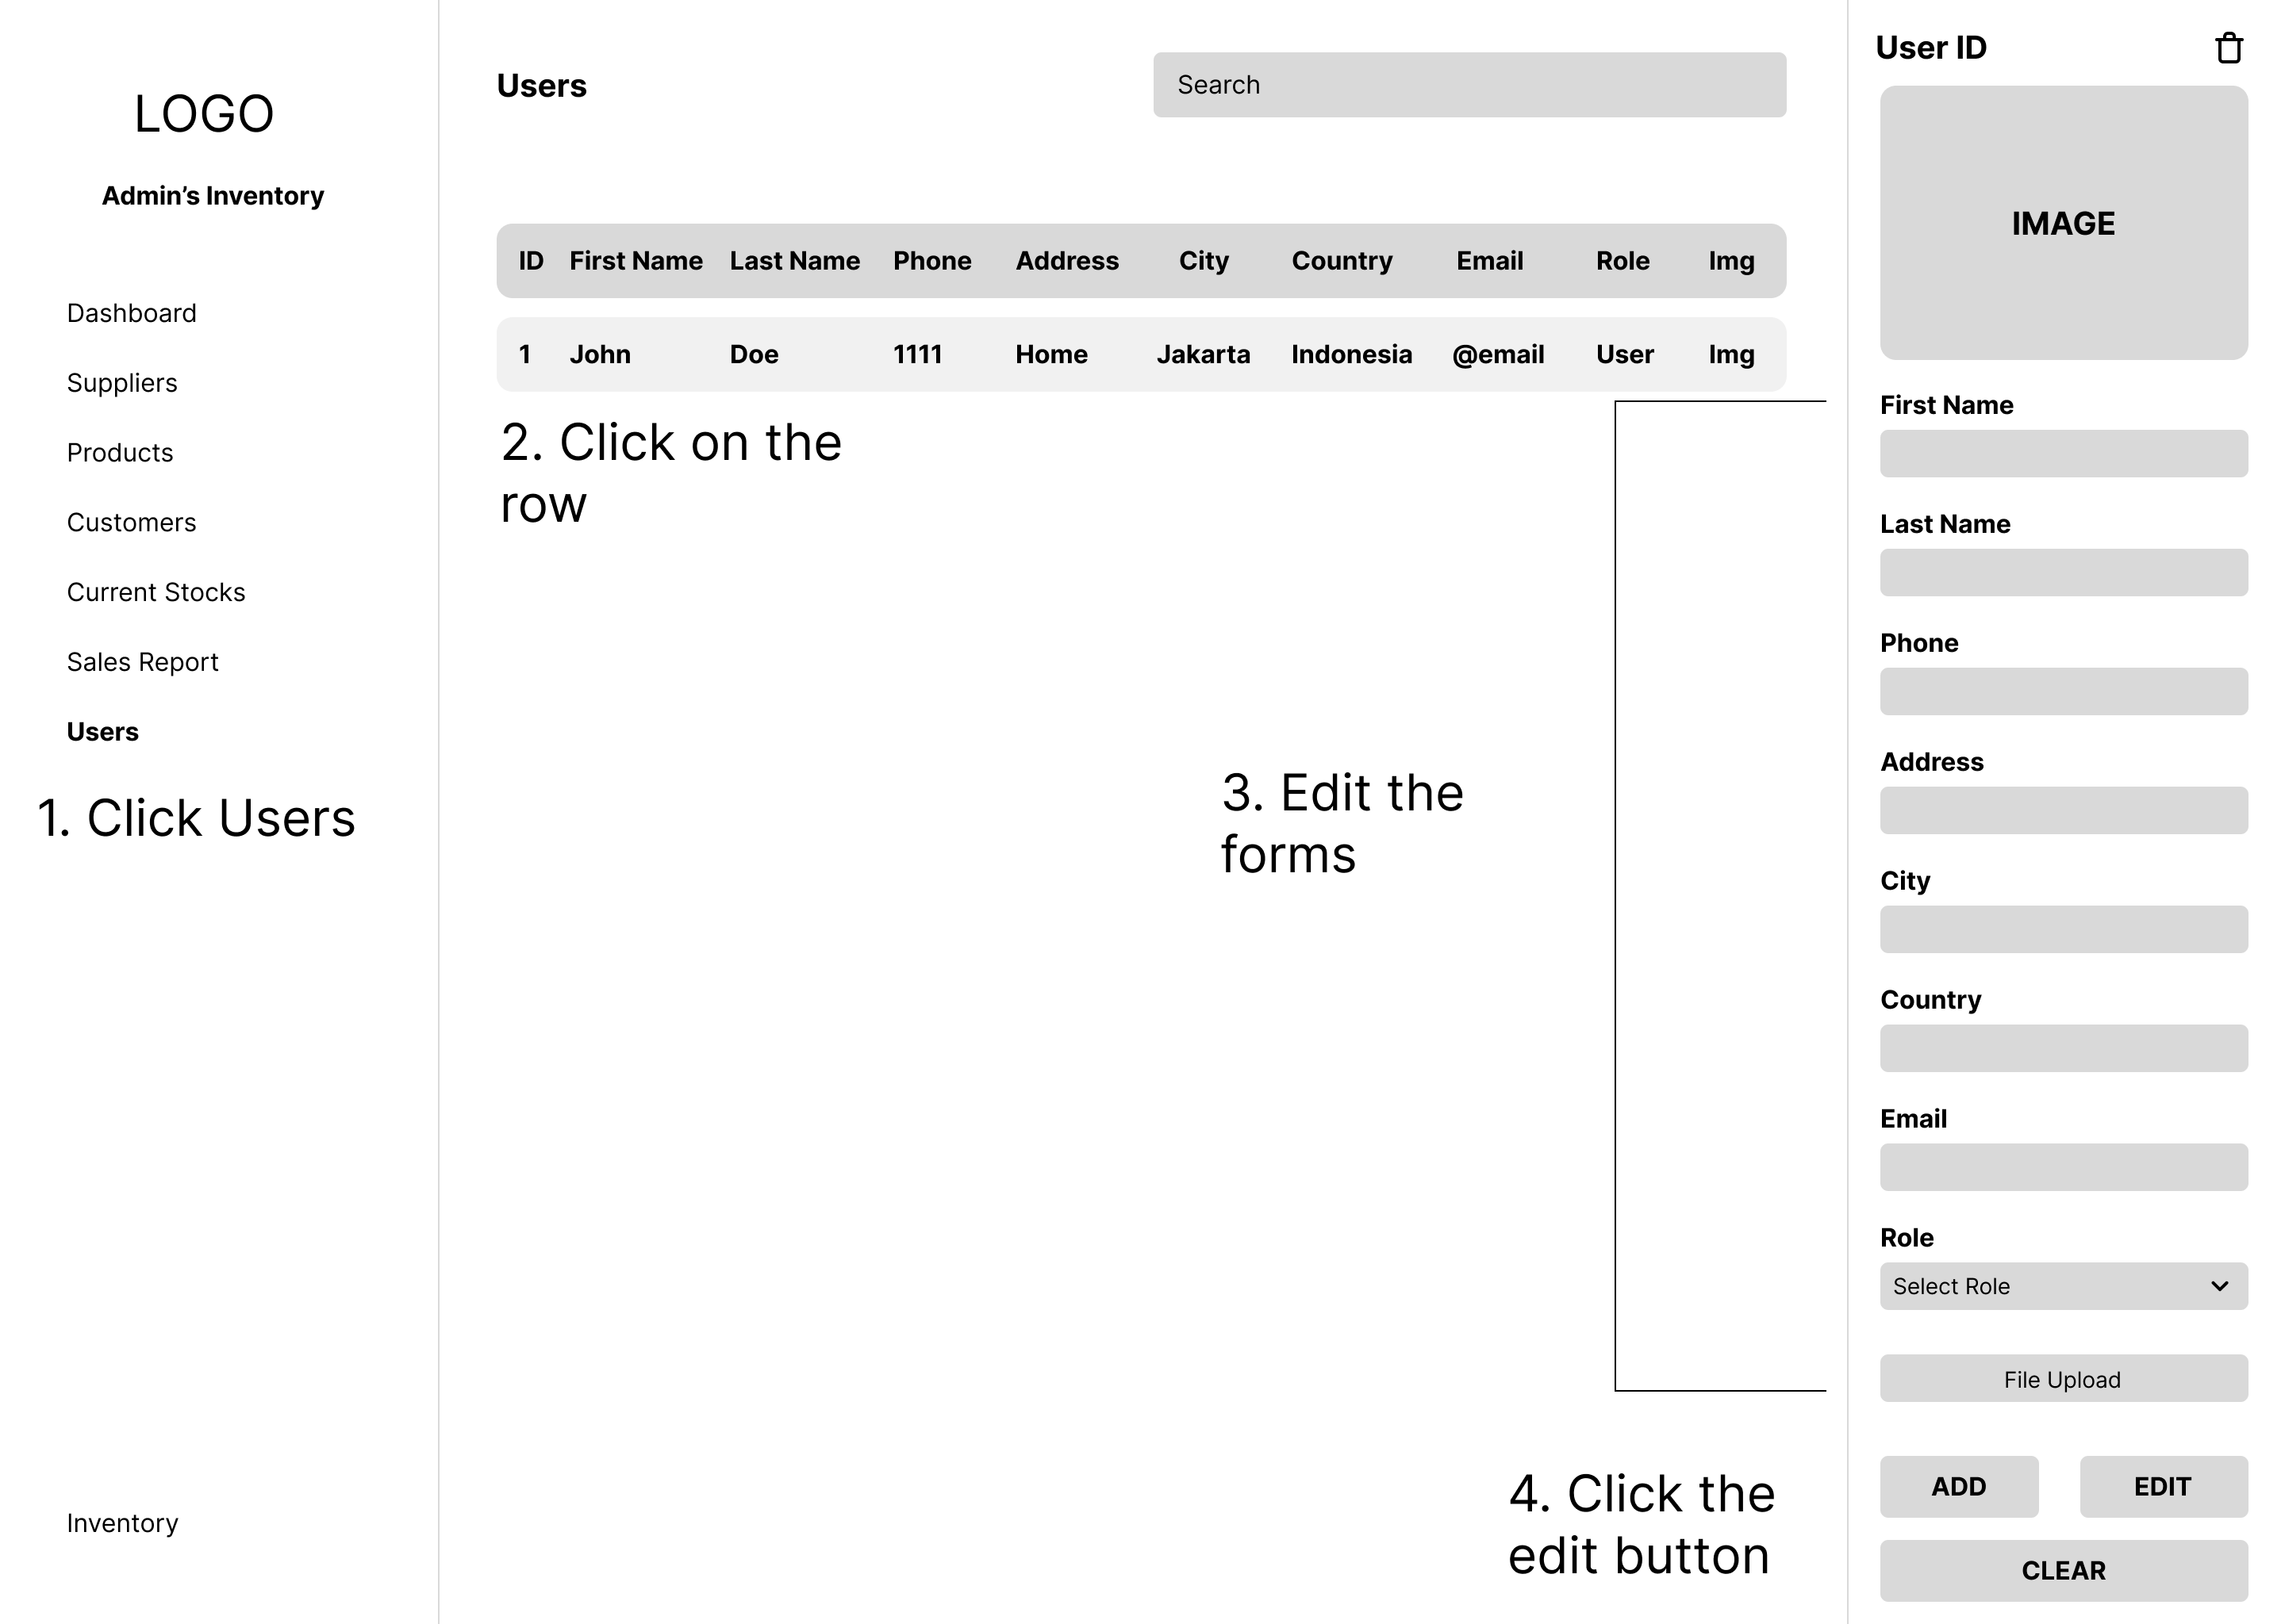**

**Delete user  
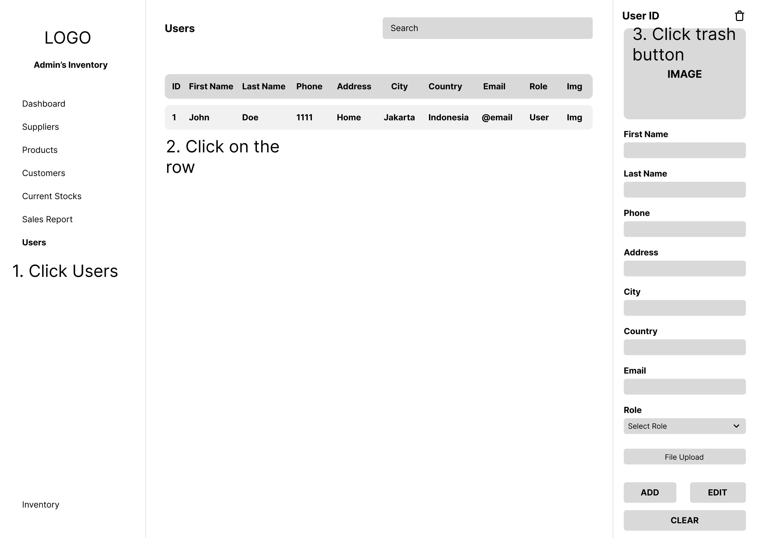**

**View Sales Report  
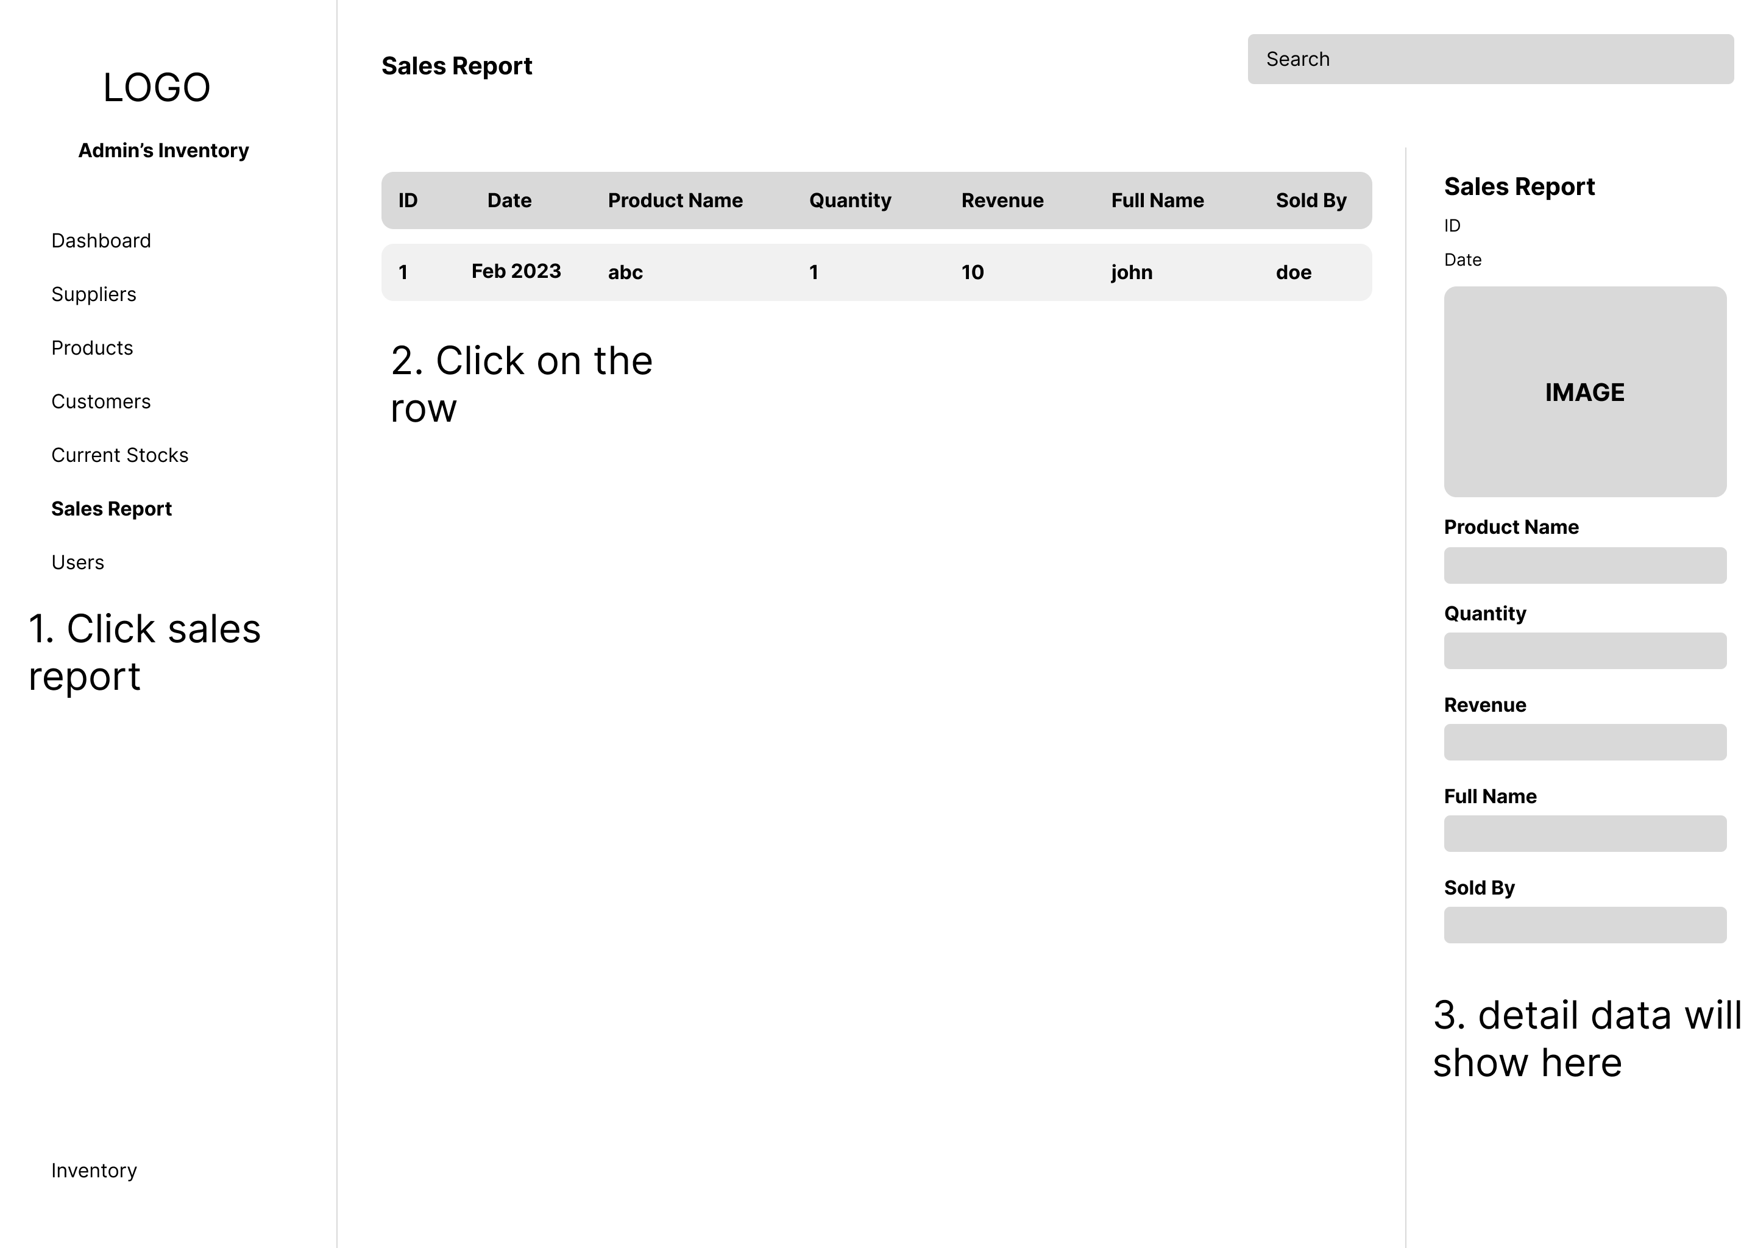**

1. Entity Relationship Diagram (ERD)

Entity Relationship Diagrams, also referred to as ER Diagrams, ER Models, or ERDs, are a type of structural diagram used in database design. The major entities included in the system scope as well as the relationships between these entities are both visually represented by an ERD's various symbols and connectors.

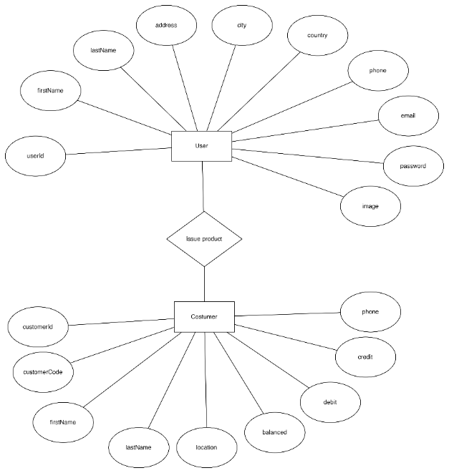

Selling products to customers

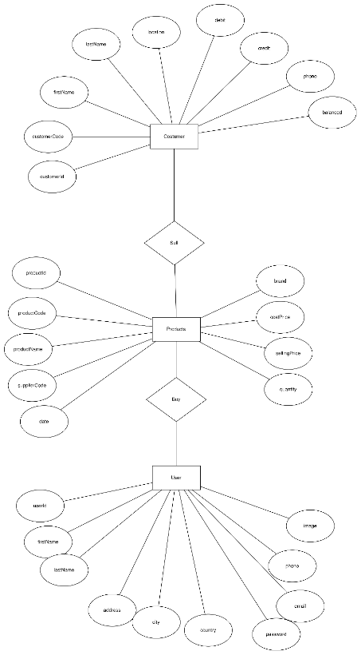

Buying product from suppliers

1. Database Schema

A database schema specifies the logical constraints, including table names, fields, data types, and the connections between these entities, that govern how data is arranged in a relational database. Schemas serve as the cornerstone of an organization's data management discipline by frequently using visual representations to communicate the database architecture. Data modeling is another name for the process of designing a database schema.

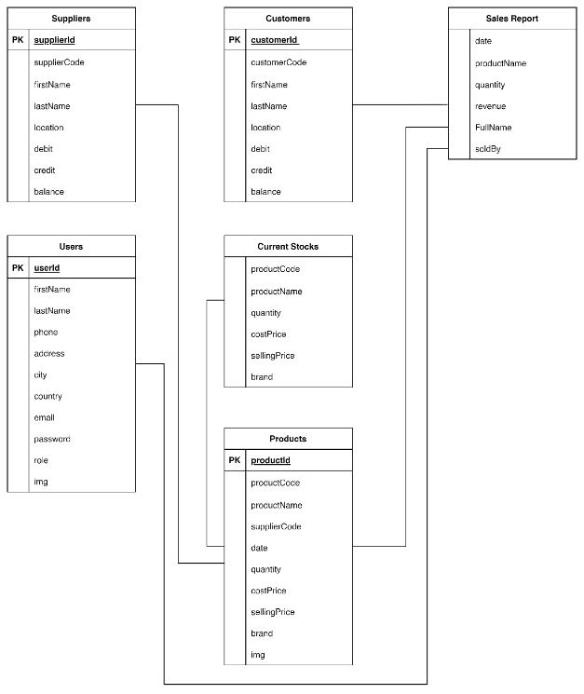

## Communication with Stakeholders

|  |  |  |  |  |
| --- | --- | --- | --- | --- |
| **Sender** | **Receiver** | **Purpose** | **Medium** | **Frequency** |
| Acedora PM | Jumpstart Emplyee/customer | Communicate to provide the solution & recommendation | Microsoft Teams | Once in project Life Cycle |
| Acedora PM | Senior Manager of Acedora | Update project progres | Email, Microsoft Teams | Twice per week |

## Project Implementation

## Back-end source code

**App.js**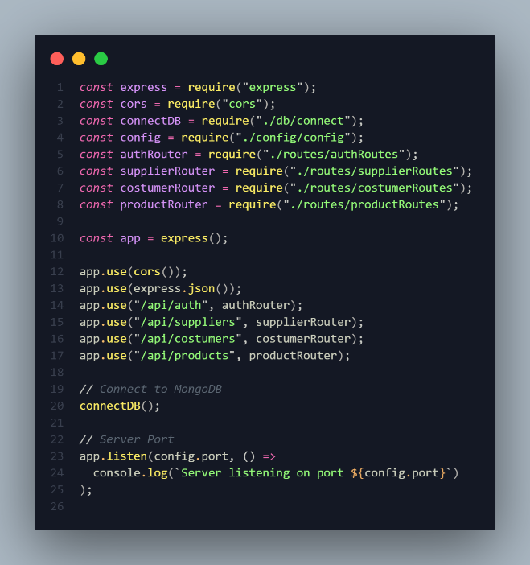

**Models.js**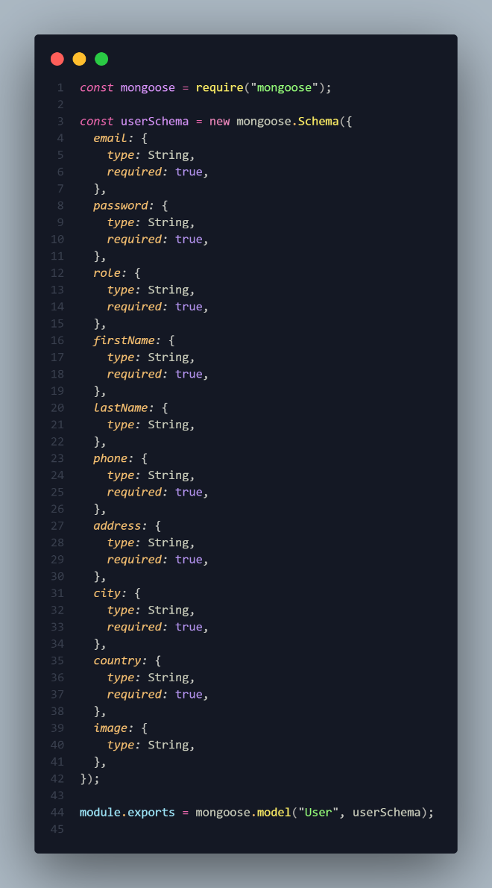

**Controllers.js**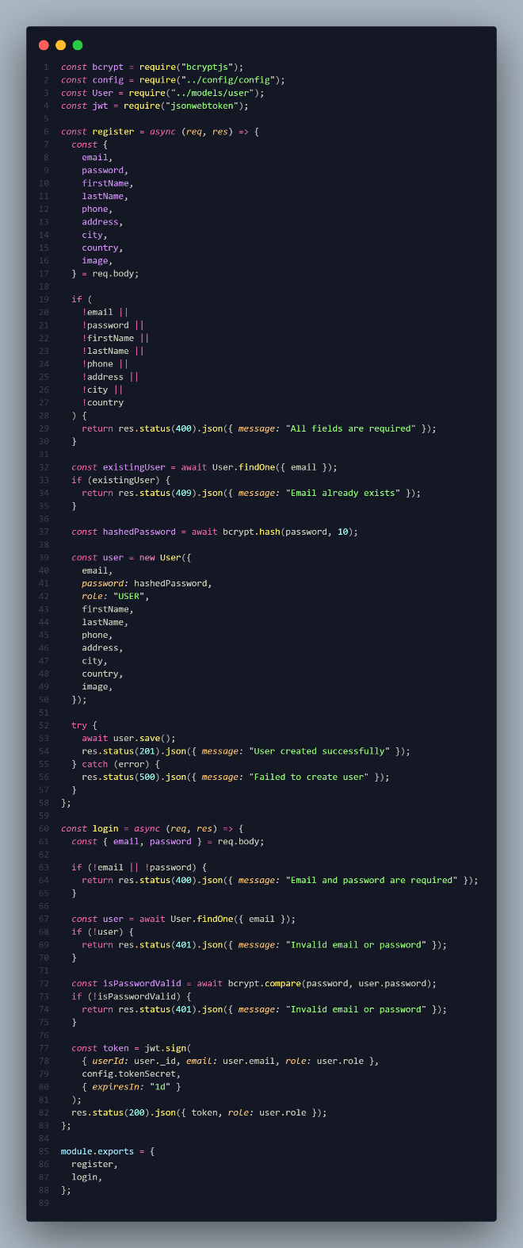

**Middlewares.js**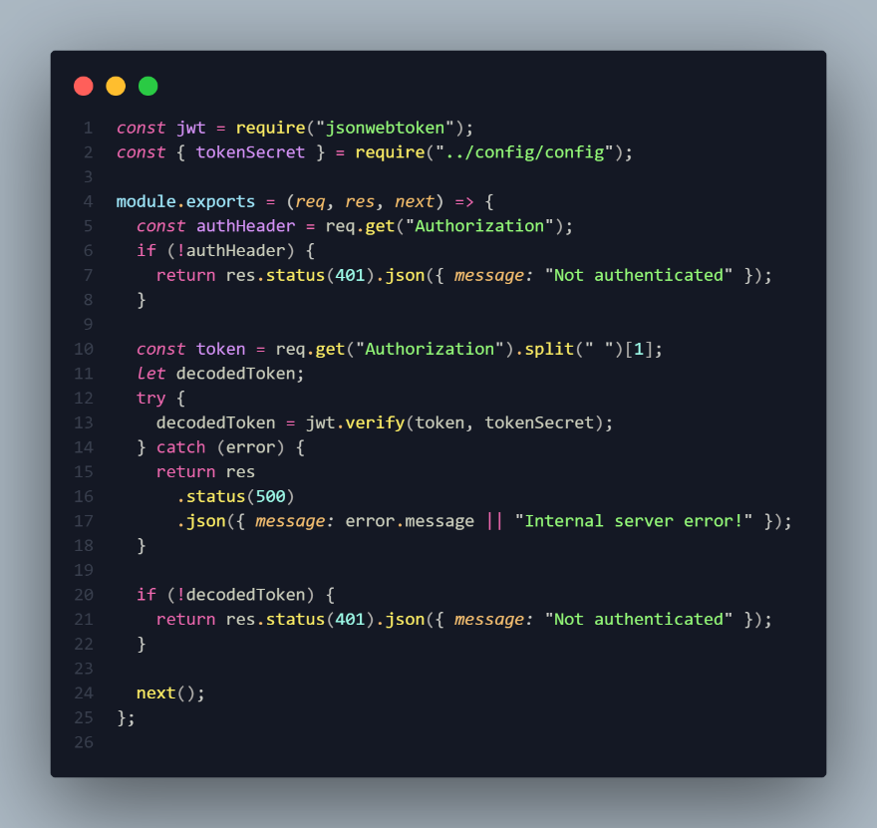

**Routes.js**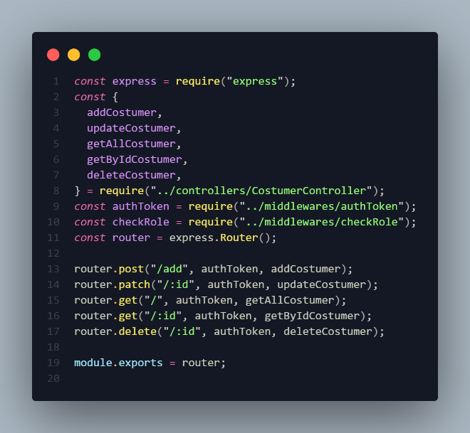

## Front-end source code

**Home Page  
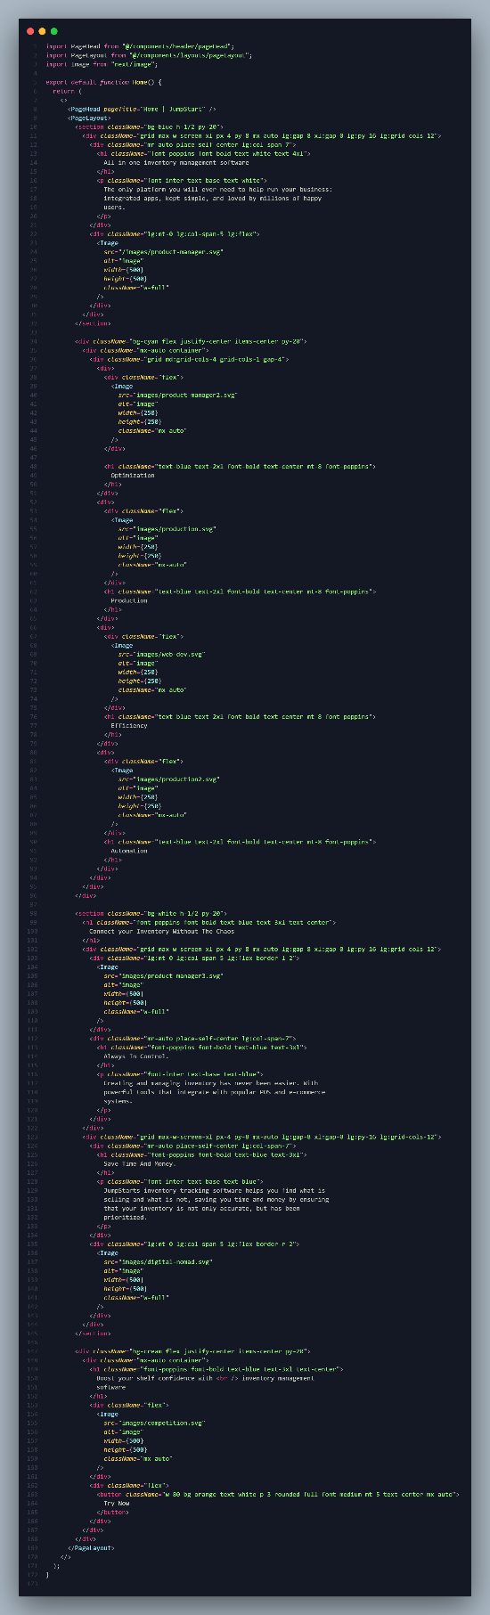**

**Contact Page  
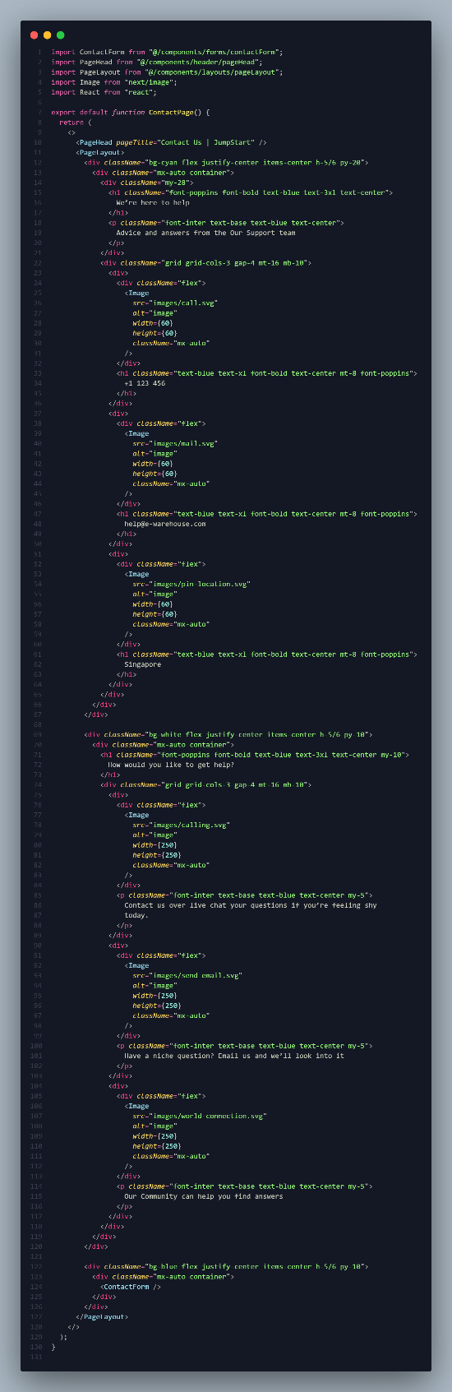**

**About Us Page  
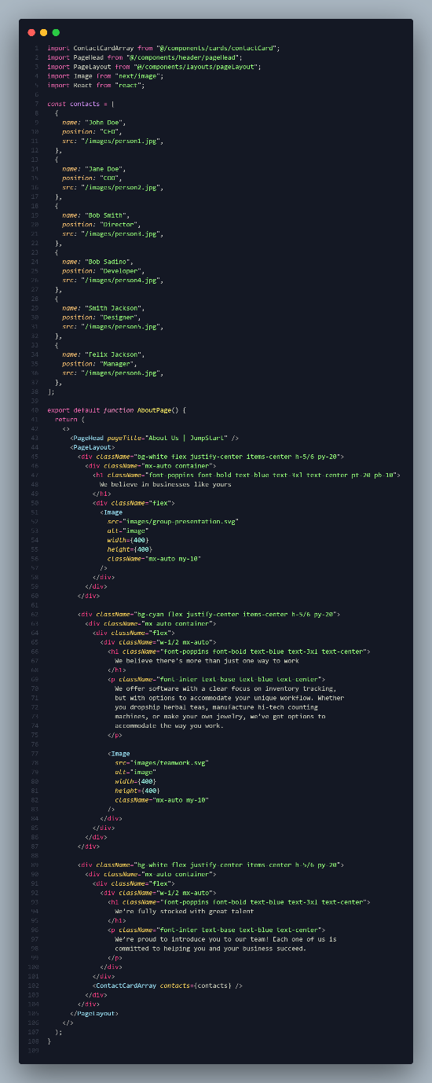**

**Login  
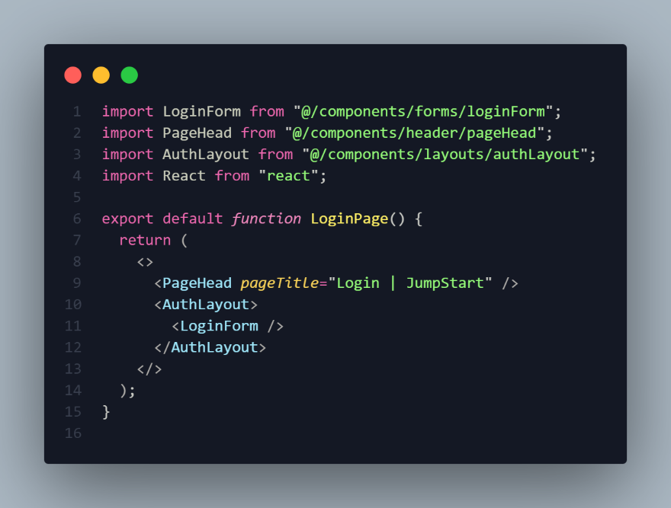**

**Register  
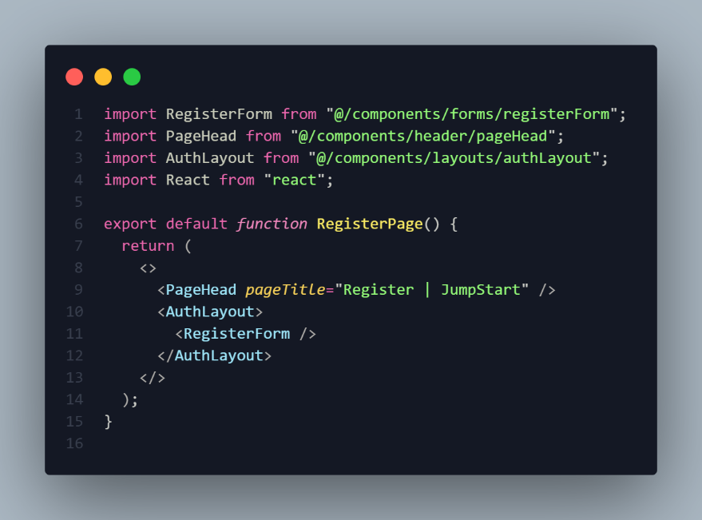**

**Dashboard  
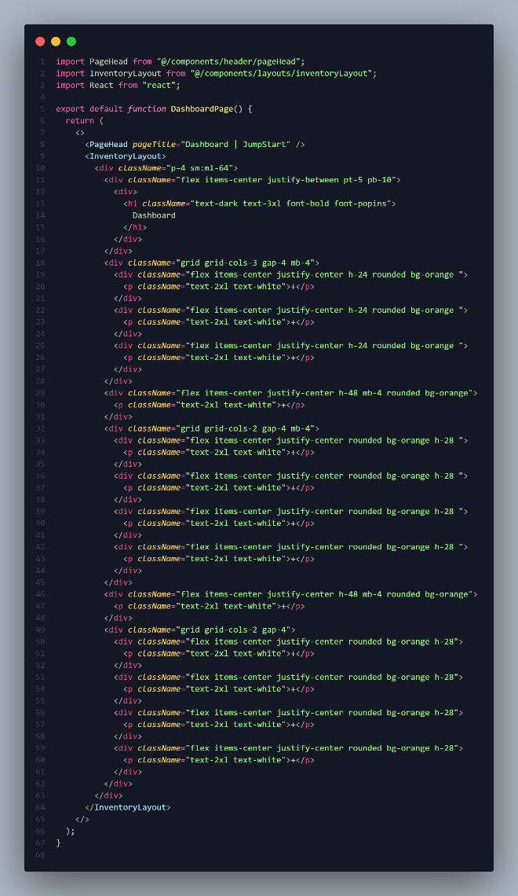**

**Inventory Page (Suppliers, Products, Costumers, Current Stocks, Sales Report, and Users Page)  
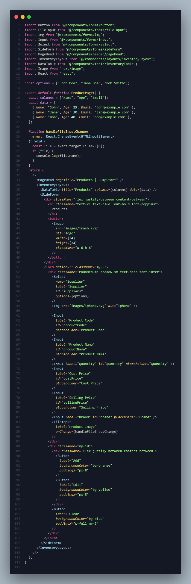**

## White box testing

White box testing is a testing method that examines the internal organization, coding, and design of software in order to validate input-output functionality and enhance design, usability, and security. White box testing is also known as clear box testing, open box testing, transparent box testing, code-based testing, and glass box testing because code is visible to testers during this type of testing.

Test all controller mappings using POSTMAN tool and then record your result:

1. Register  
   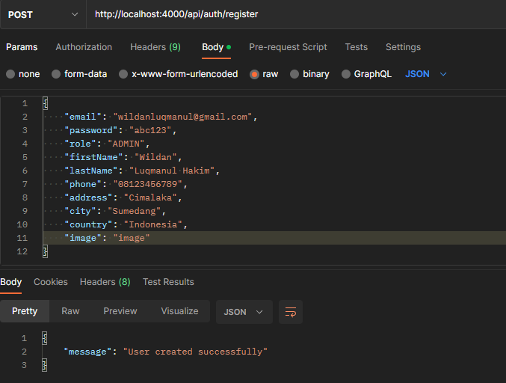
2. Login  
   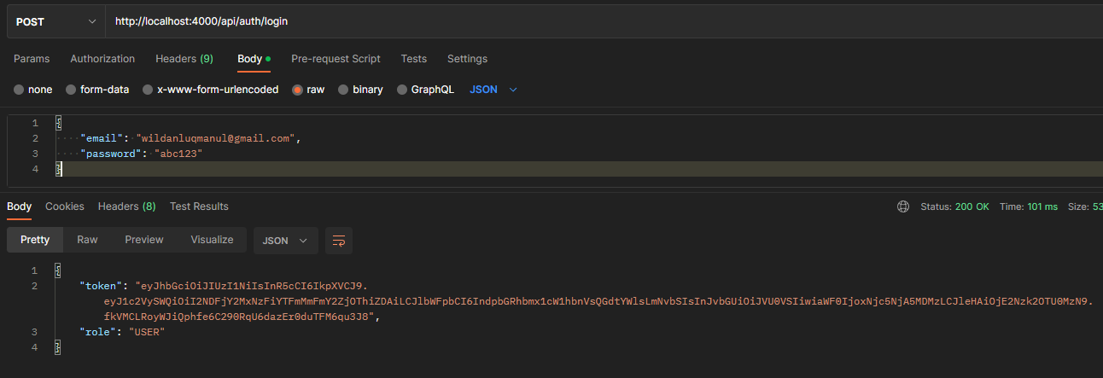
3. Add Supplier  
   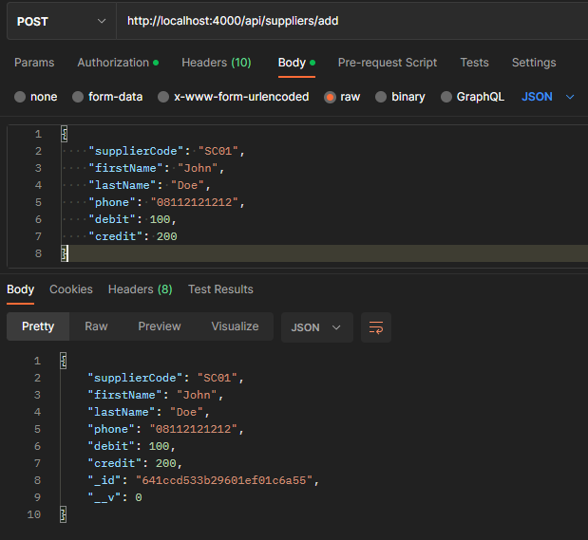
4. Get All Supplier  
   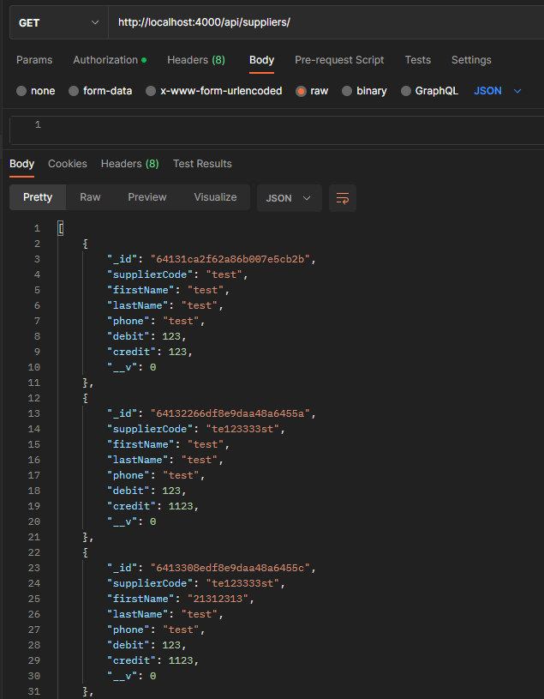
5. Get Supplier by Id  
   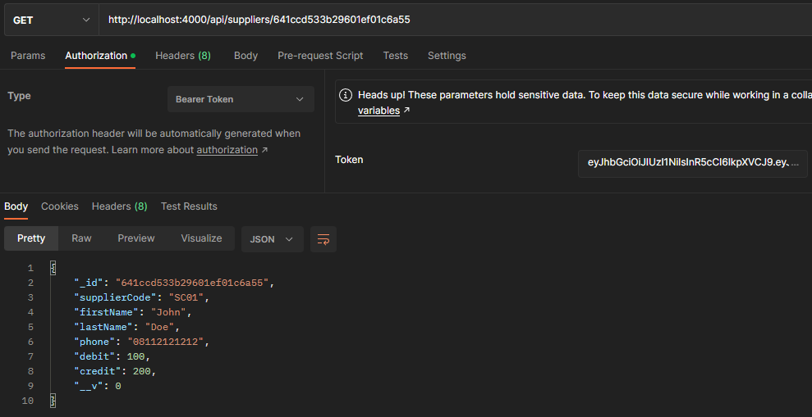
6. Update Supplier  
   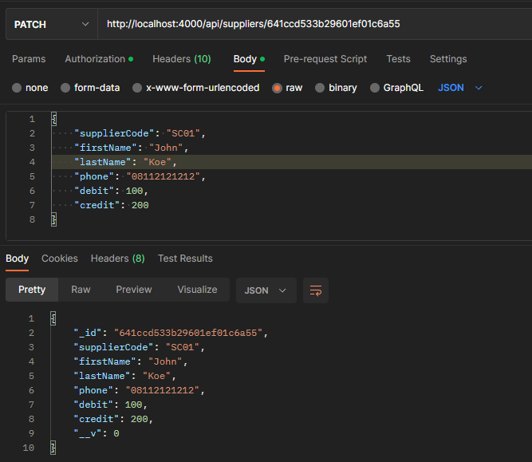
7. Update Supplier  
   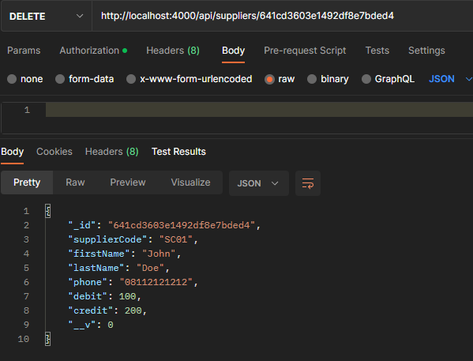
8. Add Costumer  
   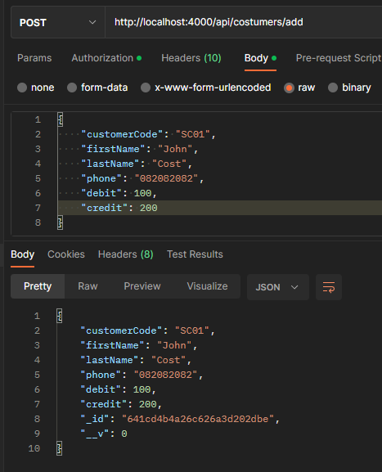
9. Get All Costumers  
   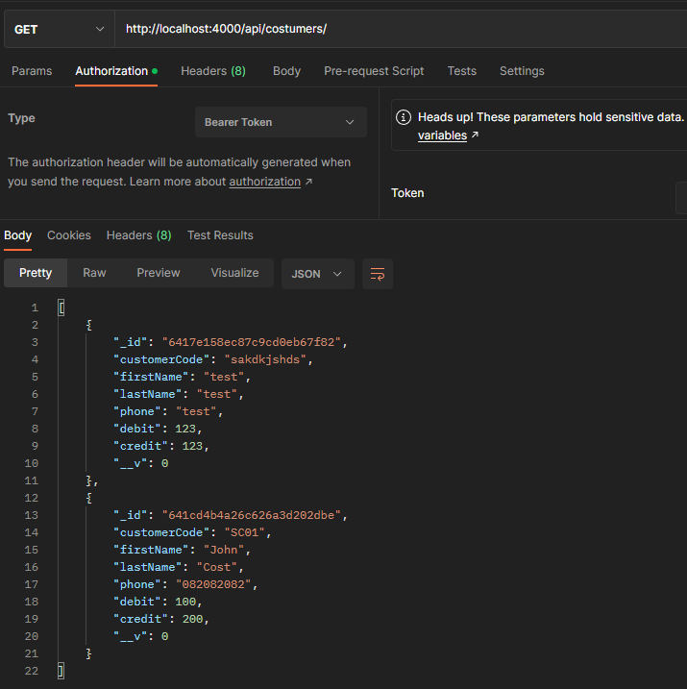
10. Get Costumer by Id  
    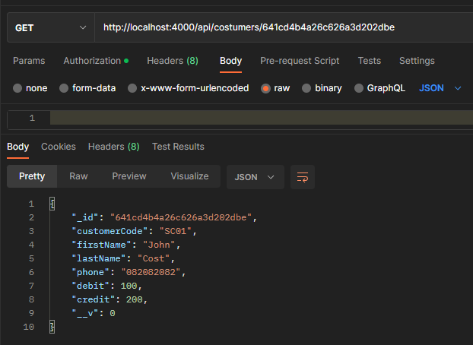
11. Update Costumer  
    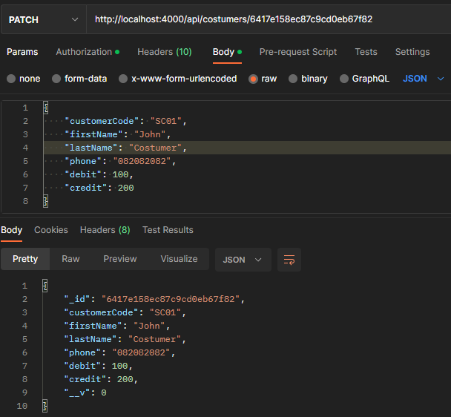
12. Delete Costumer  
    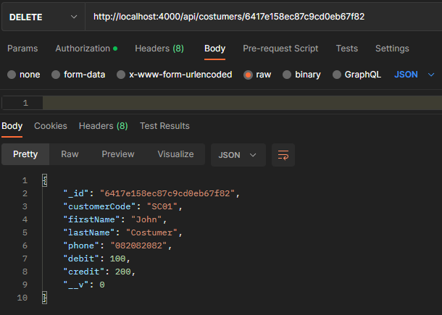

## Black box testing

Black box testing is a technique for testing software applications' functionalities without having access to their internal code structure, implementation specifics, or internal paths. Black Box Testing is entirely based on software requirements and specifications and primarily concentrates on the input and output of software applications. Additionally called behavioral testing.

**Testing Plan**

|  |  |  |
| --- | --- | --- |
| Test Scenario ID | Test Scenario | Number of test cases |
| TS001-Unit testing | Ensure SQLI is prevented | 3 |
| TS002-Cross Browser testing | Ensure website is compatible with multiple browser | 3 |
| TS003-UAT testing | 1. Ensure user navigation is easy | 2 |

**Scenario 1**

|  |  |  |  |  |  |  |
| --- | --- | --- | --- | --- | --- | --- |
| **Scenario ID** | **Risk No** | **Test Scenario** | **Preconditions** | **Test Step** | **Test Data** | **Expected Results** |
| TS001 | 2 | User Login | User has the URL of the website | 1. Type in URL 2. Click on login 3. Enter fields with test data 4. Click submit | Email=user' or '1' = '1  Password=pass' or '1' = '1 | Login fail |
| TS001 | 2 | User Login | User has the URL of the website | 1. Type in URL 2. Click on login 3. Enter fields with test data 4. Click submit | Email=ali@gmail.com  Password=pass' or '1' = '1 | Login fail |
| TS001 | 2 | User Register | User has the URL of the website | 1. Type in URL 2. Click on login 3. Enter fields with test data 4. Click submit | Email=ali@gmail.com  Password=Robert'); DROP TABLE Students; -- | Table not dropped |

**Scenario 2**

|  |  |  |  |  |  |  |
| --- | --- | --- | --- | --- | --- | --- |
| **Scenario ID** | **Risk No** | **Test Scenario** | **Preconditions** | **Test Step** | **Test Data** | **Expected Results** |
| TS002 | 3 | User direct to dashboard page | Google Chrome is downloaded | 1. Enter website URL 2. Click on register 3. Register as new user 4. Login with newly registered user 5. View dashboard 6. Logout | Email=user@gmail.com  Password=abc123 | Webpages appears as expected and functionality work as expected |
| TS002 | 3 | Member view daily meal | Firefox is downloaded | 1. Enter website URL 2. Click on register 3. Register as new user 4. Login with newly registered user 5. View dashboard 6. Logout | Email=user@gmail.com  Password=abc123 | Webpages appears as expected and functionality work as expected |
| TS002 | 3 | Member view daily meal | Edge is downloaded | 1. Enter website URL 2. Click on register 3. Register as new user 4. Login with newly registered user 5. View dashboard 6. Logout | Email=user@gmail.com  Password=abc123 | Webpages appears as expected and functionality work as expected |

**Scenario 3**

|  |  |  |  |  |  |  |
| --- | --- | --- | --- | --- | --- | --- |
| **Scenario ID** | **Risk No** | **Test Scenario** | **Preconditions** | **Test Step** | **Test Data** | **Expected Results** |
| TS003 | 5 | Test Case 1 | Users logged in | 1. Navigate to view dashboard page 2. Navigate to view suppliers page 3. Navigate to products page 4. Navigate to customers page 5. Navigate to current stocks page |  | User can navigate to target page easily |
| TS003 | 5 | Test Case 2 | Admin logged in | 1. Navigate to view dashboard page 2. Navigate to view suppliers page 3. Navigate to products page 4. Navigate to customers page 5. Navigate to current stocks page 6. Navigate to sales report page 7. Navigate to manage users page |  | Admin can navigate to target page easily |

Results:  


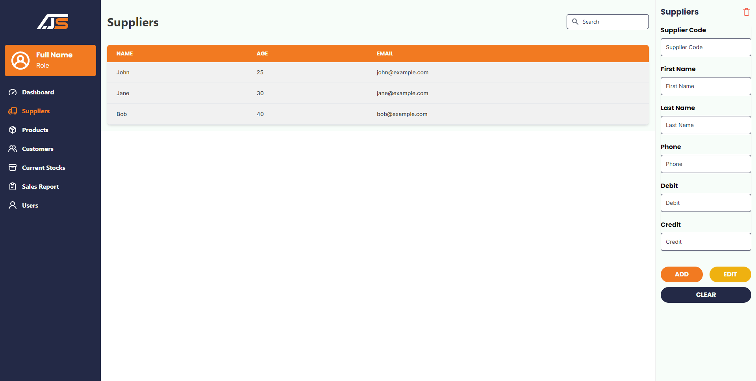

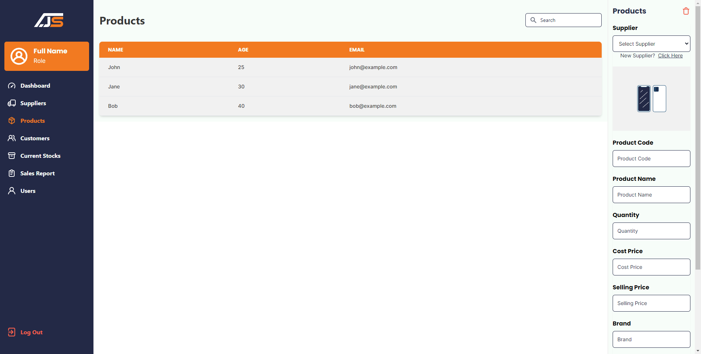

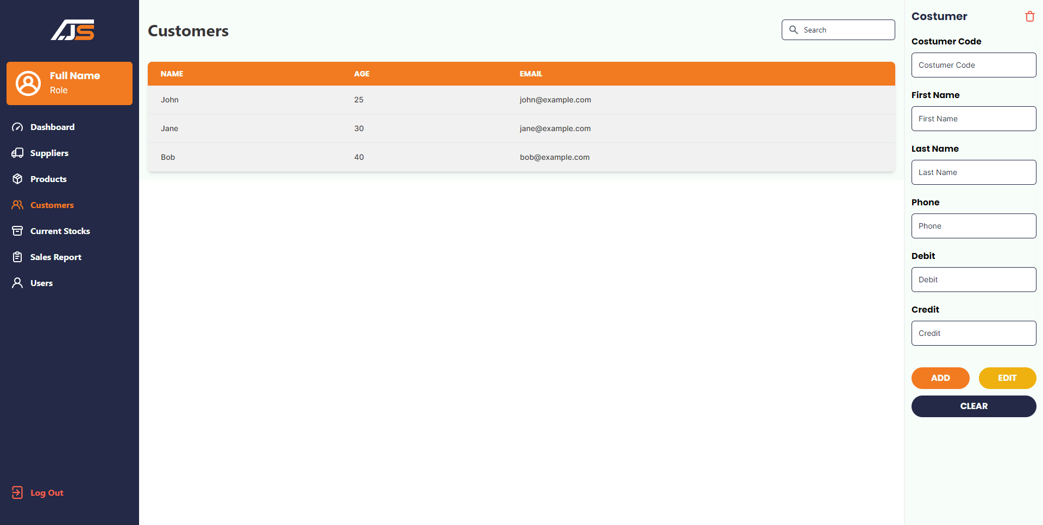

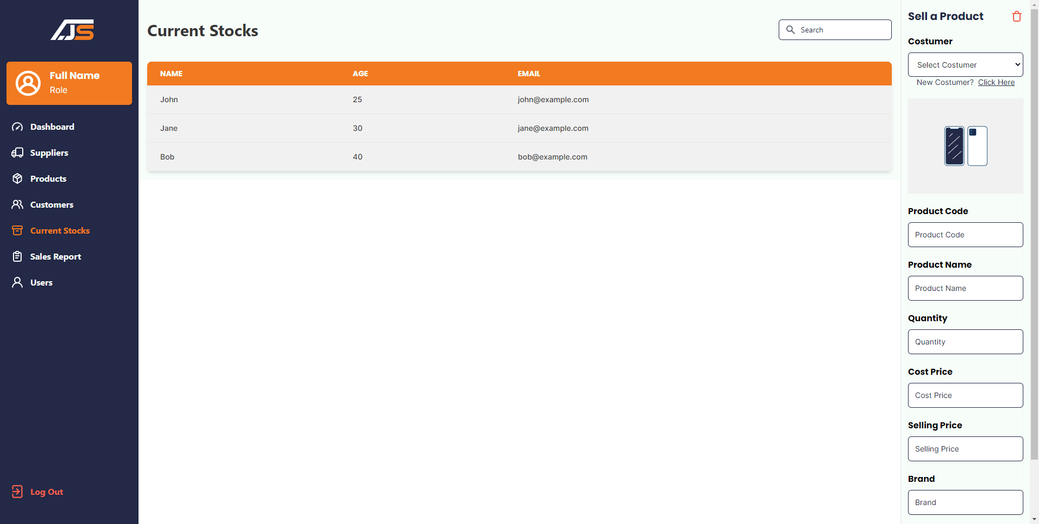

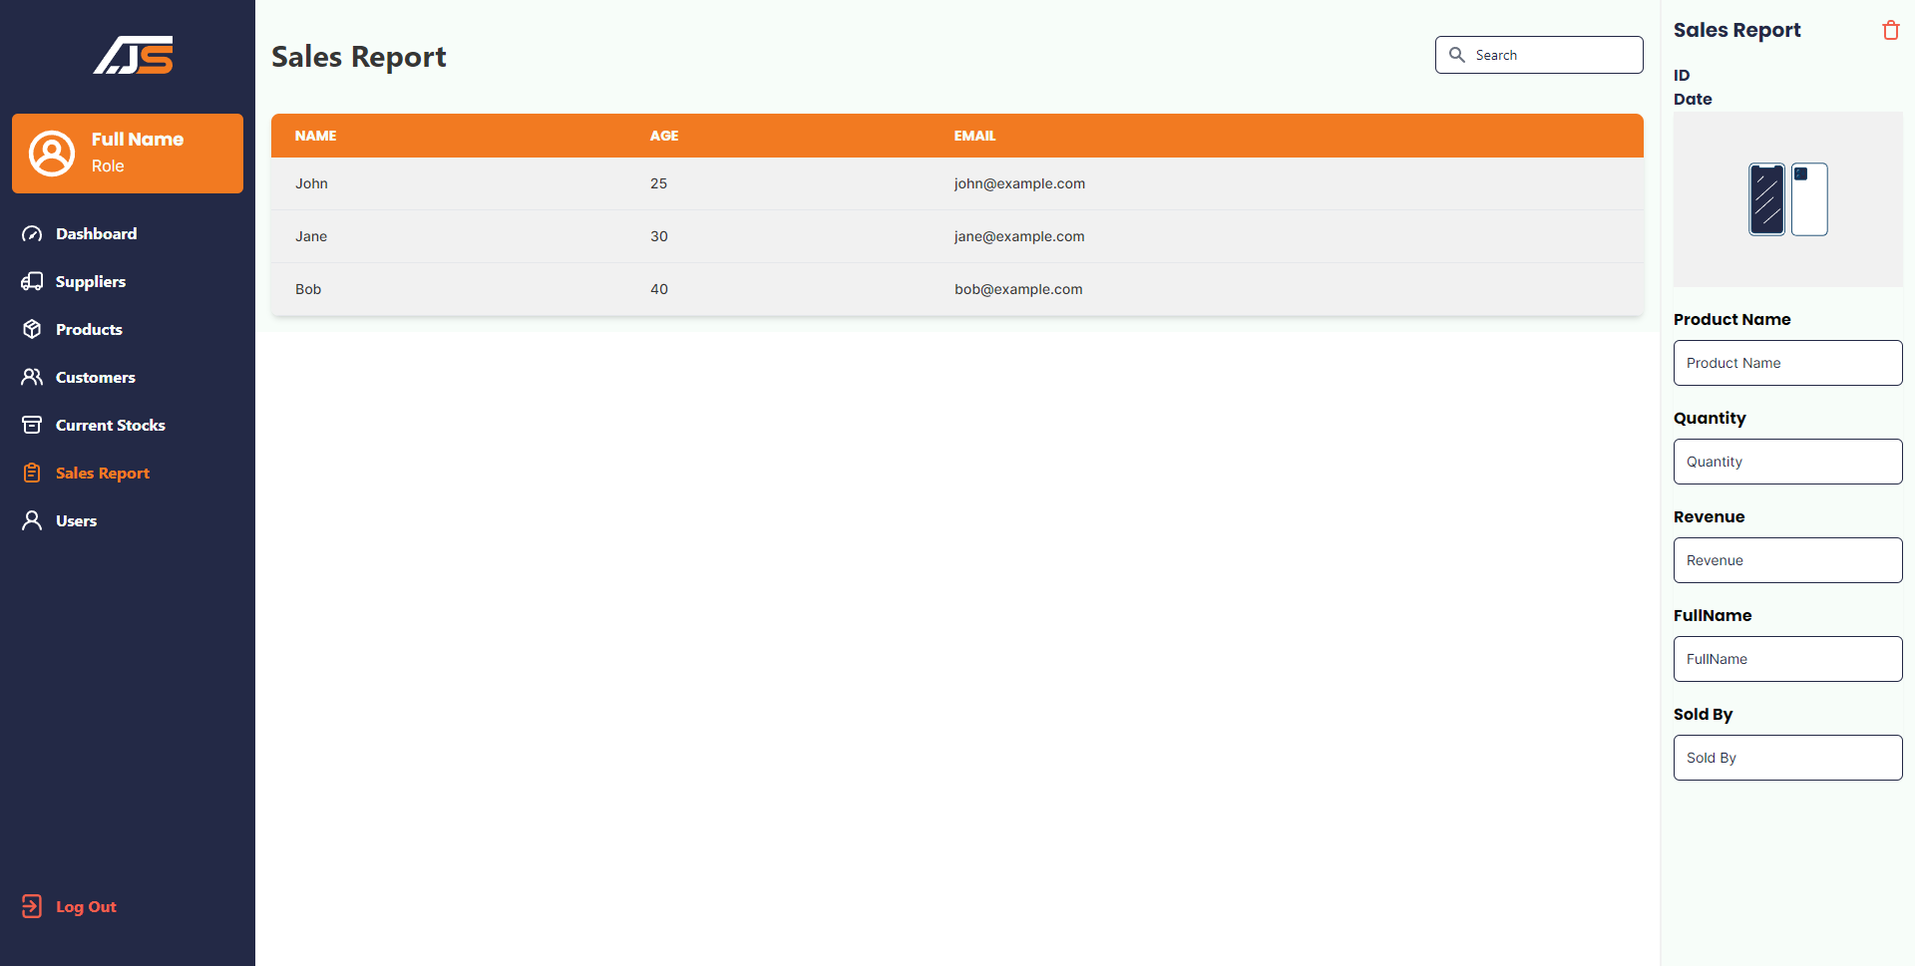

## Conclusion

In conclusion, the research on inventory management for Jumpstart has provided insights into the challenges faced by the retail chain and the potential solutions to overcome them. The study has identified the importance of a well-designed inventory management system in improving business efficiency and enhancing customer satisfaction. Through the use of various research methods, including primary and secondary research, a comprehensive understanding of the topic was achieved.

The research revealed that the adoption of technology such as inventory management software, data analytics, and RFID systems can significantly improve the inventory management process for Jumpstart. The integration of these technologies will enable the company to track inventory levels accurately, reduce stockouts, and optimize order fulfillment processes.

Additionally, the research identified the importance of employee training and development in implementing successful inventory management practices. Through regular training sessions and workshops, employees can understand the importance of inventory management and acquire the necessary skills to manage inventory effectively.

Overall, the research on inventory management for Jumpstart highlights the need for a well-designed and implemented inventory management system that can enhance business efficiency and customer satisfaction. By implementing the recommended solutions, Jumpstart can remain competitive in the retail industry and achieve sustainable growth.

## Bibliography

Leticia, M., & Álvarez, B. (2016). Inventory management practices and operational performance: An empirical investigation in retail firms. International Journal of Production Economics, 171, 381-393.

Fawcett, S. E., & Magnan, G. M. (2002). The rhetoric and reality of supply chain integration. International Journal of Physical Distribution & Logistics Management, 32(5), 339-361.

Lee, H. L., Padmanabhan, V., & Whang, S. (1997). The bullwhip effect in supply chains. Sloan Management Review, 38(3), 93-102.

Kelle, P., Woensel, T. V., & Kok, A. G. (2014). Inventory routing for perishable products: A review. European Journal of Operational Research, 237(1), 1-14.

Huang, S. H., & Keskar, H. (2007). An analytical framework for evaluating just-in-time production systems. International Journal of Production Economics, 107(1), 223-240.

Powell, T. C., & Dent-Micallef, A. (1997). Information technology as competitive advantage: The role of human, business, and technology resources. Strategic Management Journal, 18(5), 375-405.

Gupta, A., & Maranas, C. D. (2003). Managing demand uncertainty in supply chain planning. Computers & Chemical Engineering, 27(8), 1219-1227.